Mifare 1 Smart Locking System


Contents

1. Software installations： 3
2. Load software 9
3. Software settings: 12
3.1. Room Types 12
3.2. Create rooms 14
3.3. Create public doors 18
3.4. Create Members 19
3.5. Time card 23
3.6. Lift management (Create lift): 24
3.7. Encoder installation 31
3.8. System ID card 34
3.9. Lock setting card 36
3.10. Public door setting 40
3.11. Lift setting 43
3.12. Emergency cards 46
3.13. Staff card 49
3.14. Issue “Temporary card” 59
3.15. Authorizing card 61
3.16. Assign member (Operator log in) 62
3.17. Terminating card (S70 card) 71
3.18. Query card 73
4. Trouble and shooting 79
4.1. Getting SID 79
4.2. Run software occurring Error 82
5. Explanations 86
5.1. Setting 86
5.2. Energy Saver 87
5.3. Back up and restore database 88
5.4. How to find out the software’s version? 88
5.5. Reset SN Card 89
6. Handheld operations 90

Software installations
Find out Be-tech installation “exe” file and double click.
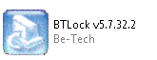

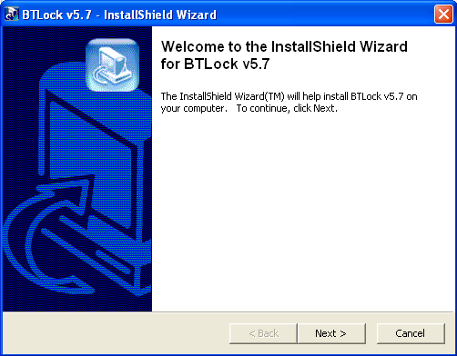
Double click the file and prepare to install
Click Next

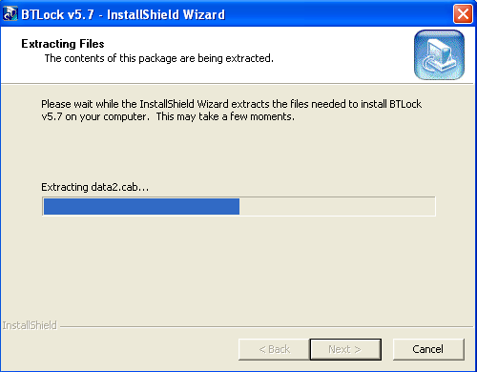

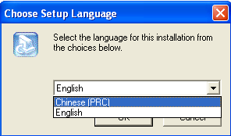
Choose language of the software.

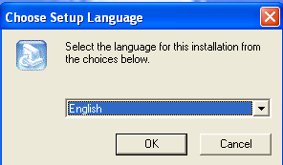

Click “OK”

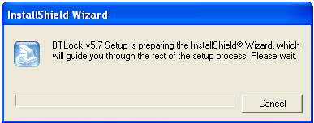

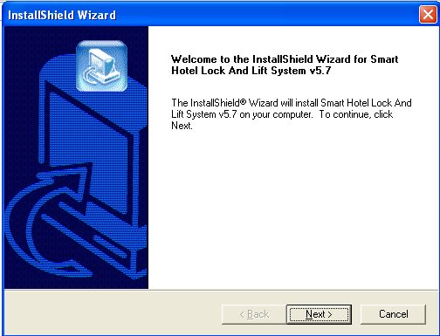

Click “OK”

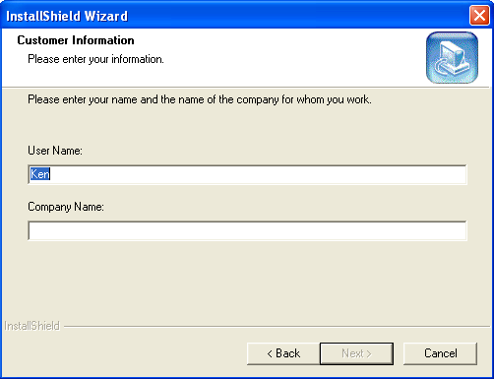

Enter the use name and company name.

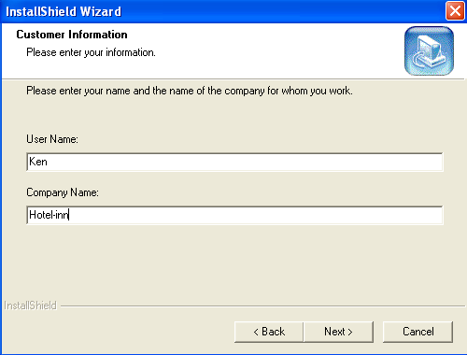

Click “Next”

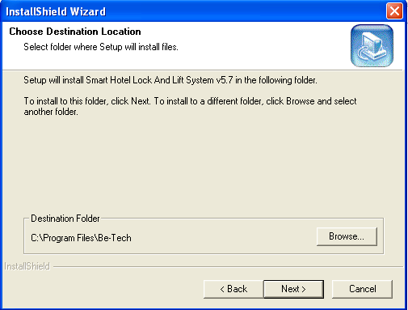

Click “Next”

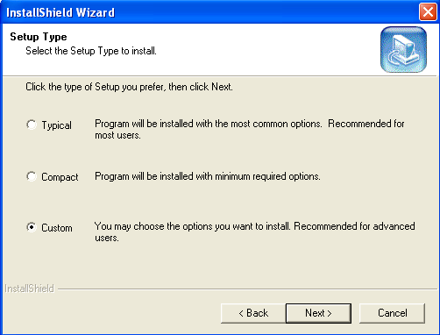

Choose “Custom”
And
Click “Next”

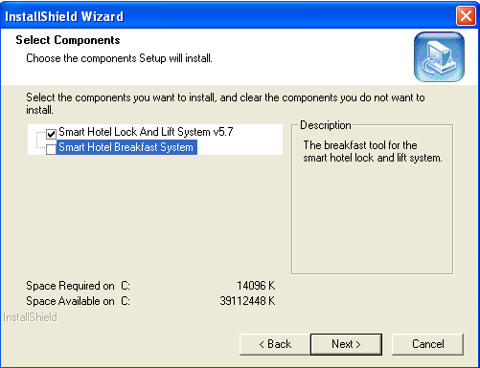

There are two options, you can only install the “Smart Hotel Lock and Lift System V5.7”, or select all

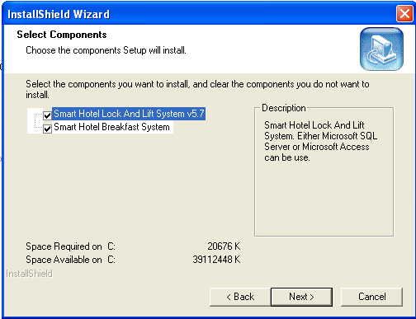

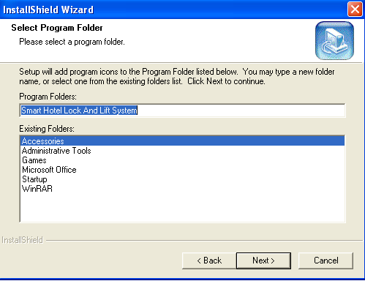
Click “Next”

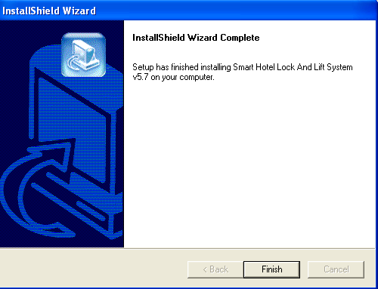
Click “Finish”

The installation
is completed

,.

After installation, you will see one icon on the desktop as you select “Smart Hotel Lock and Lift System V5.7”. 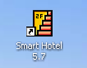
After installation, you will see two icons on the desktop as you select all.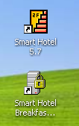

Load software
Double click the icon
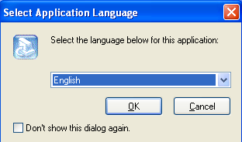

Select the application language.

The dialogue will not pop up if select “Don’t show this dialog again”

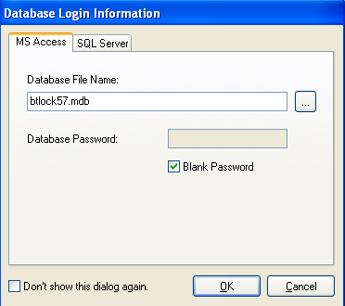

There are two databases available for Be-tech locking system, “Microsoft Access” and “SQL Server”

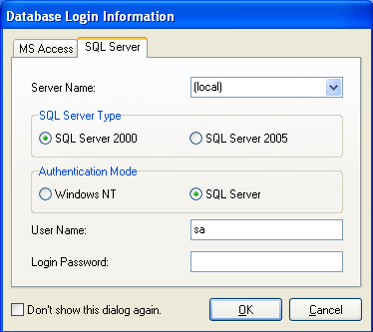

Before using SQL sever, you have to install SQL database first.

Click “OK”, you will see the screen shows as below

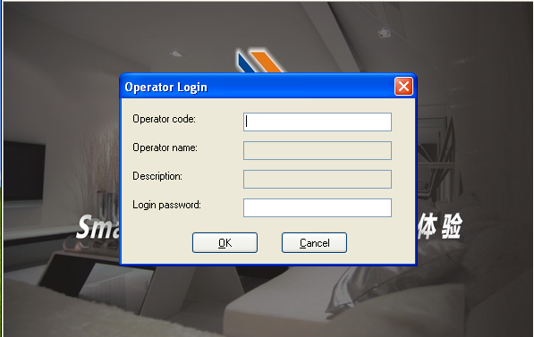

If you did not setup the operator, then you can continue as clicking “OK”, you will see as below

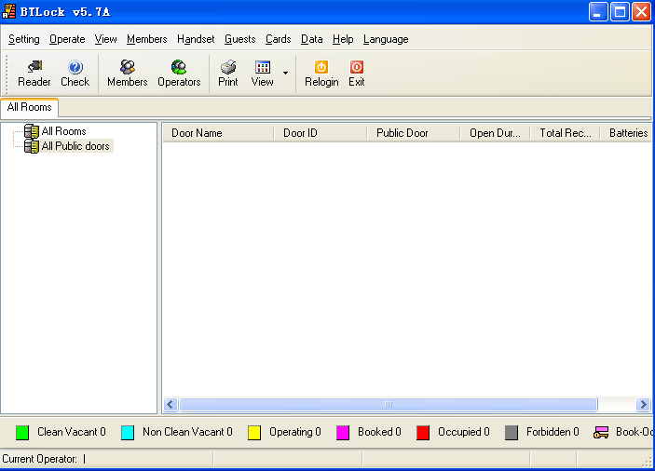

Software settings

Room Types
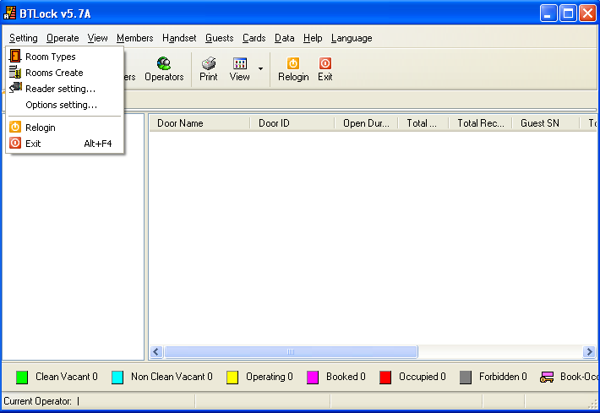
Find out “Setting”,
and
click “Room Types

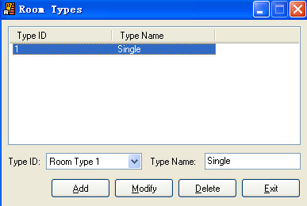

Choose the “Type ID” and enter “Type Name”, and click “Add”

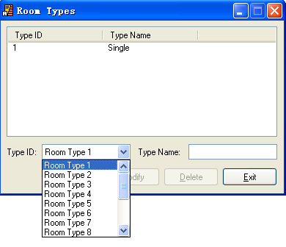

After adding all the “Room Types”, you will see the “Room Types” showing on the software.

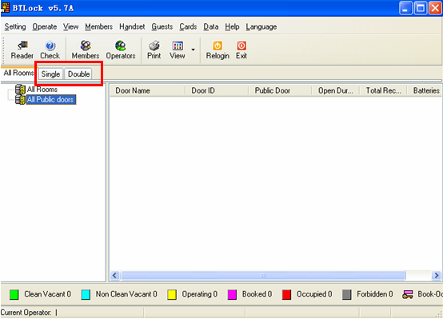

Create rooms

Create guest room
There are two types of room in the “Rooms Create”, one is “All Rooms” which is normally for guest room or some special rooms that allows specified person to getting in; the other is “All Public Doors” which allows all guests and hotel staffs to get in.
“All rooms” is normally for setting guest room.
Left click “All Rooms” to make the ground color is blue, and then click “Create Level”, the “New Building” is created. If you want to create more buildings, return to left click “All Rooms” to make the ground color is blue and click “create level”. Right click “New Buildings” to delete or rename. 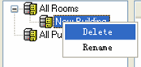, but “All Room” is only can be renamed, can’t be deleted.
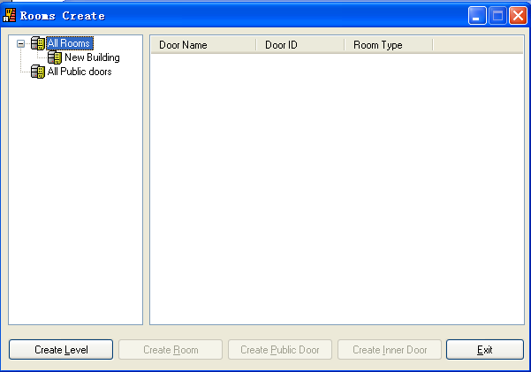

Create Rooms and setup room type

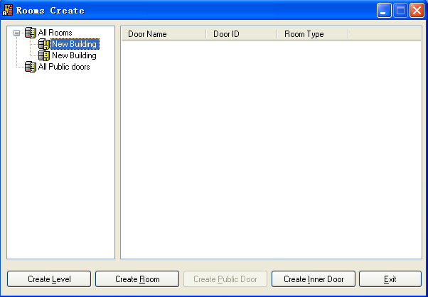
Left Click “New Building” to make the ground color is blue, and then click “create room”

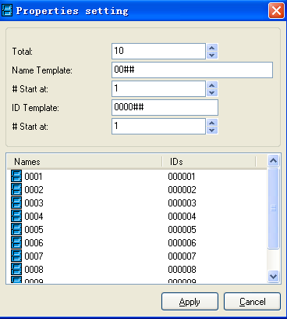

You can change “Name Template” and “ID Template”
Due to every floor own 10 rooms that we should set the total number to 10. The door name set to “10##”, the door ID set to “1000##”, both of their start number is “1”. Click the Apply button to finish the operation. Follow the above steps to add all the rooms of each floor.

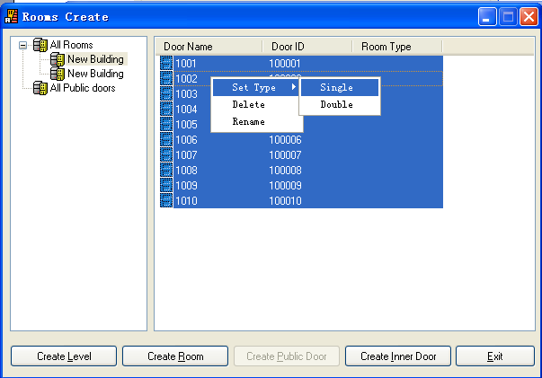
Choose the room and right click, setup the room type. You can select all rooms or one by one.

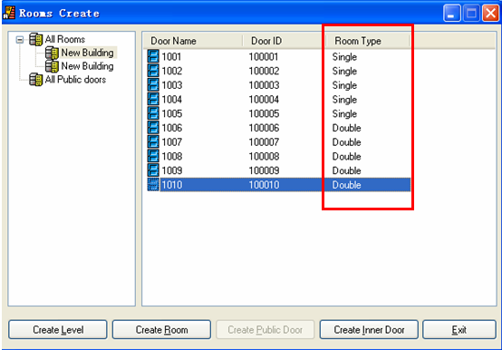

Create inner door
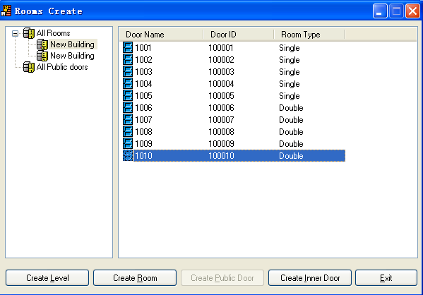
The inner door function is for normally for some big room which has an inner room. Choose the room which has the inner room and then click to make the ground color is blue, and then click “create inner room

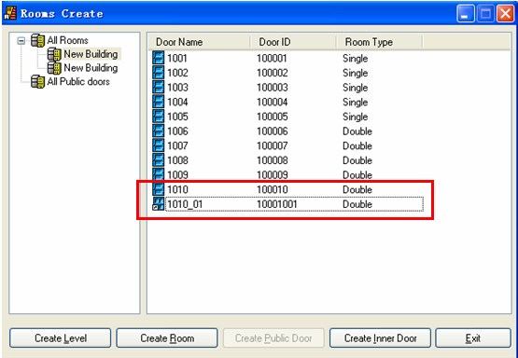

Create public doors
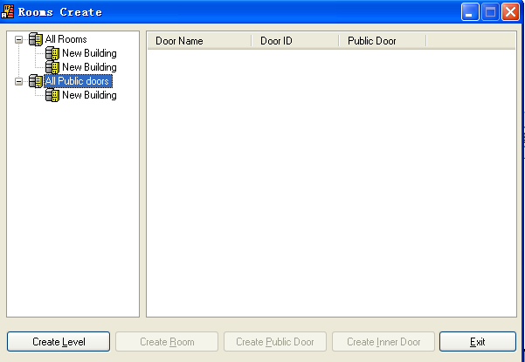
Same way as creating “All Rooms”

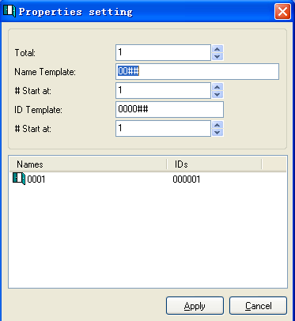

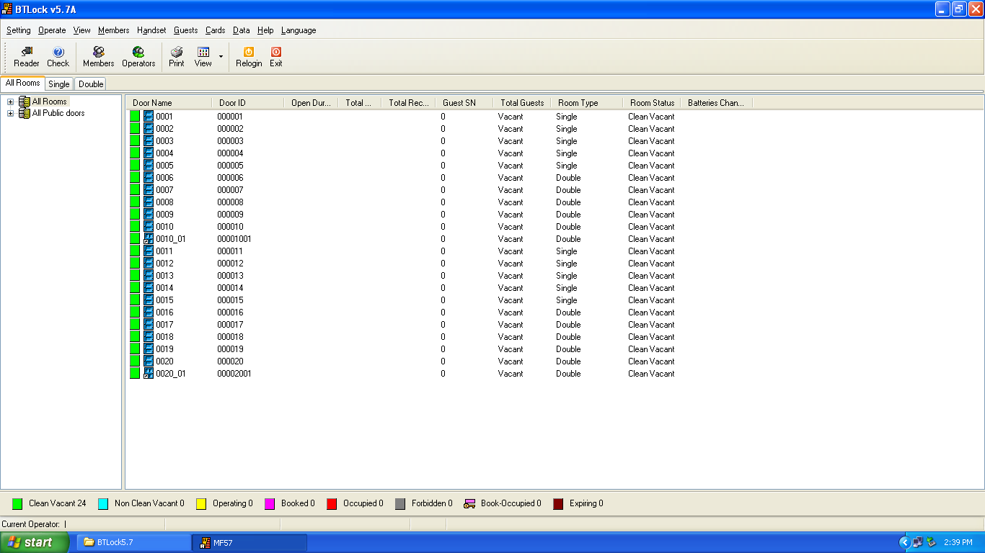
After operations, you will see all rooms on the software.

Create Members
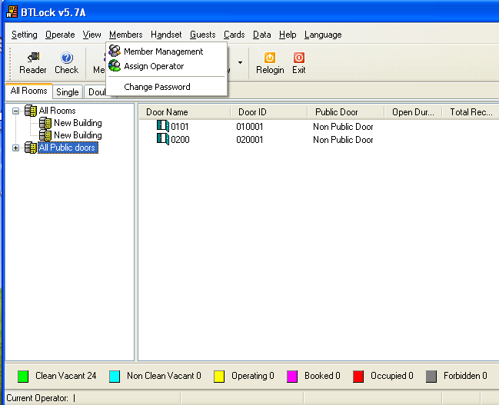
Click “Members”, choose “Member Management”

There are three items in “member Management”
1. All Emergency cards:
2. All staff cards
3. All temporary card
About their functions, please find out 3.13, 3.14, 3.15

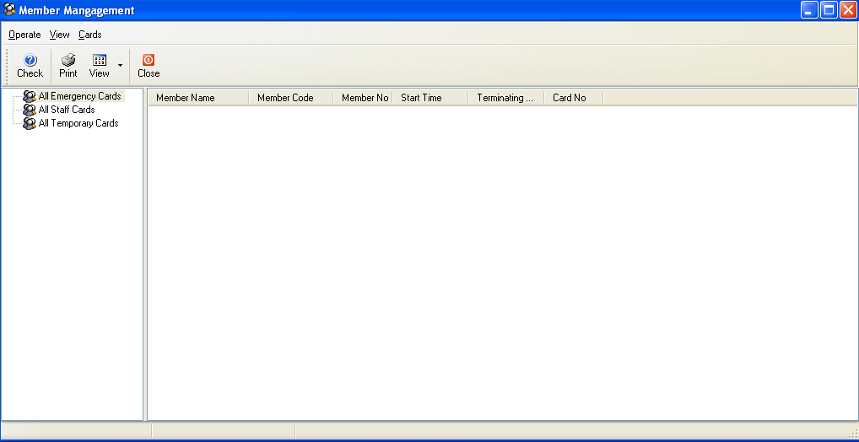

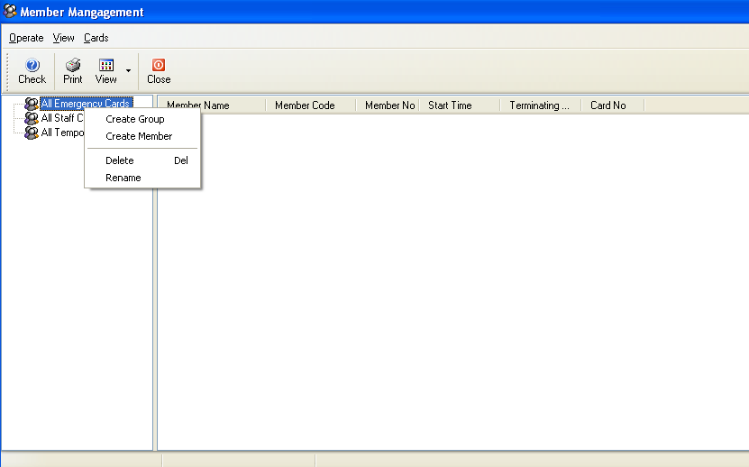
Right Click “All Emergency Cards”, you will see the options, and then click “Create Group”, “new group” is created.

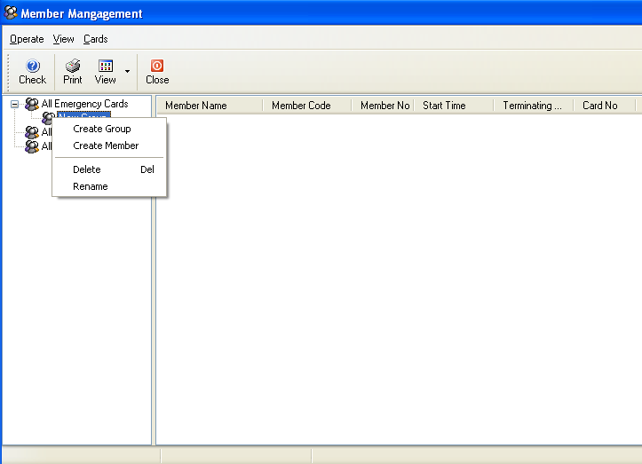
Create the members of “All Emergency Cards”

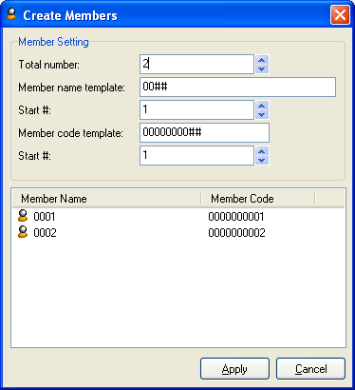
A window will turn up, now the window requires you to fill in the member information. After all the information has been registered, click the Apply button to finish the procedure and click the Cancel button to return to the system. Follow the above steps to add all the members into the system.

Notice
Every Member code template is the unique and it is a sign of member. So before the adding, please assign the code template to every member by a plan.
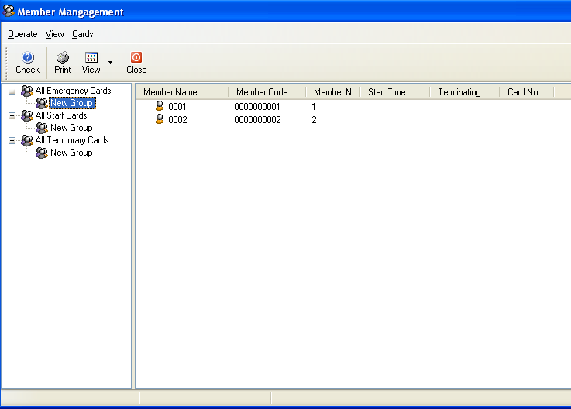

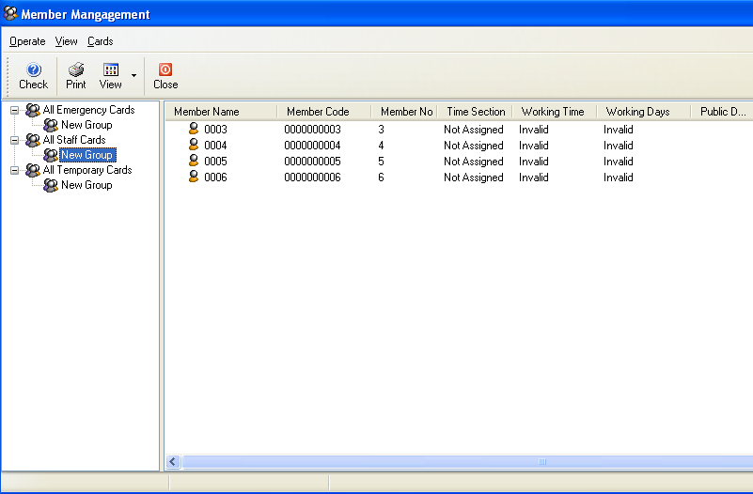
Staff card

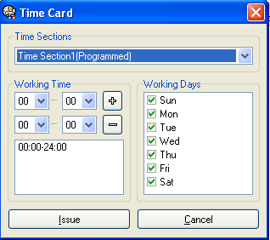

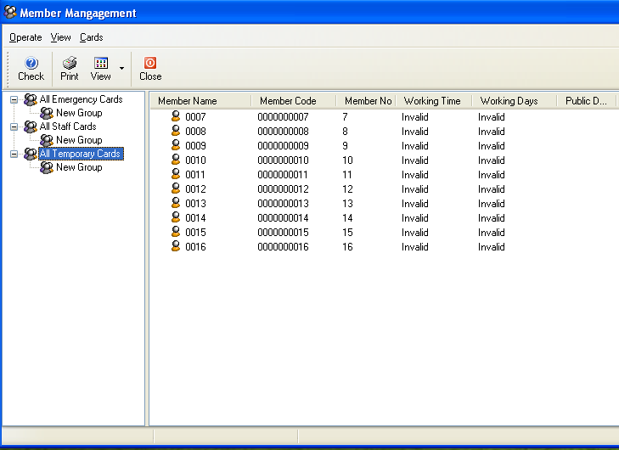

Temporary card

Time card (S70)
Time section is use to analyze the work time. Only the corresponding work time could be accept to open the door. At this case, we divide the Sunshine hotel work time into six sections like this:
Morning shift | Middle shift | Night shift | Morning shift | Middle shift | Night shift
8:00-16:00 | 16:00-00:00 | 00:00-8:00 | 8:00-16:00 | 16:00-00:00 | 00:00-8:00
Monday to Friday | Monday to Friday | Monday to Friday | Sat Sun | Sat Sun | Sat Sun

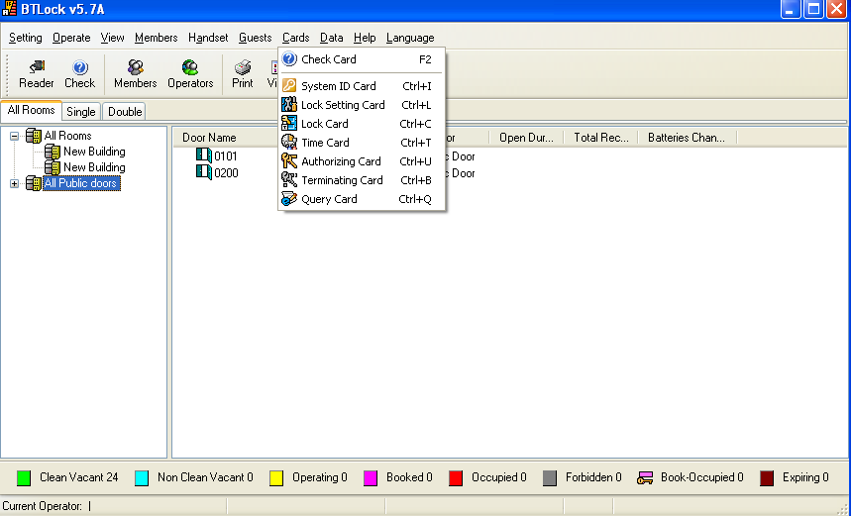

After the menu pop up, select Time Section1, the time writes 16:00-24:00, the day select the Monday to Friday, then press the Issue button to make a time card, make all the left time sections like the above procedures.

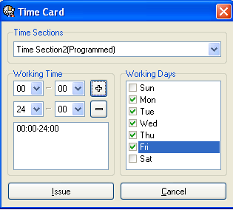

Lift management (Create lift):
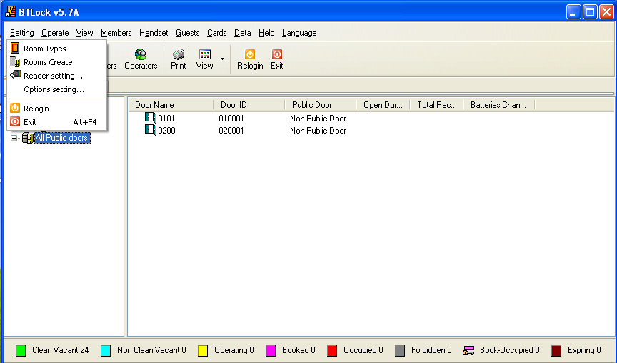

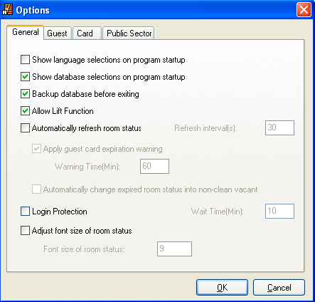

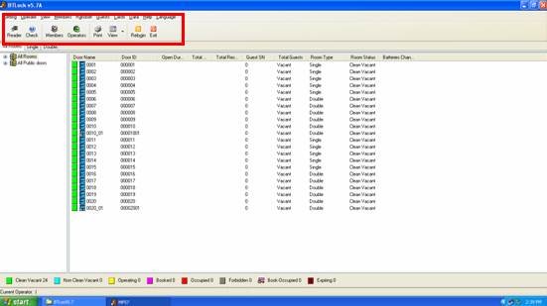
Without lift option

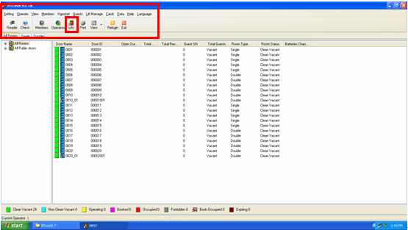
Without lift function

Click “lift” icon

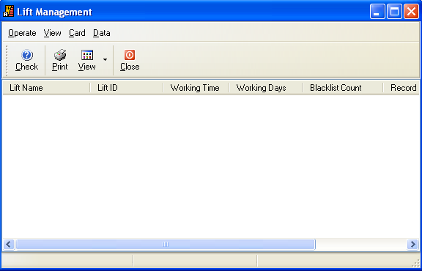
Control panel

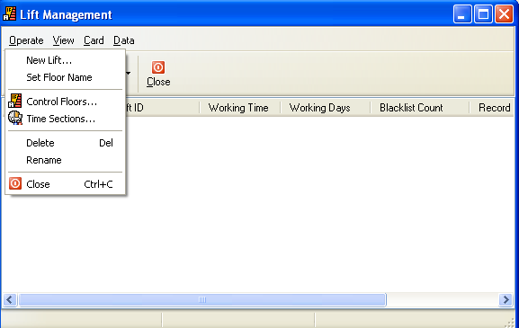
Click “Operate”

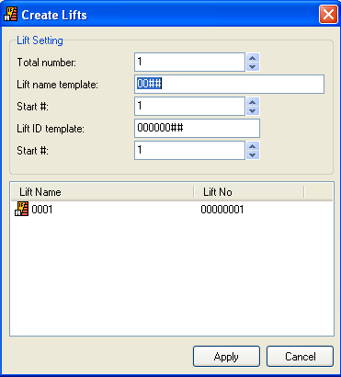

Same as create rooms.

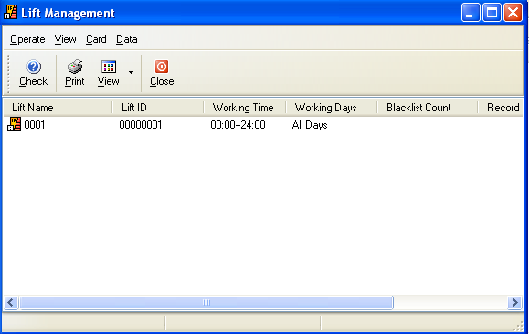

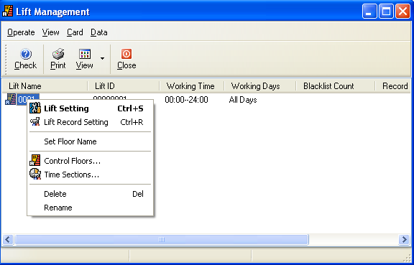

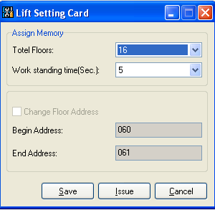
The total floor depends on the building, our controller default every 16 floors for selecting. For example, there are 23 floors in the hotel; you need to select 32 on the “Total Floors”.
Work standing time: it is control interval to operate the lift button.

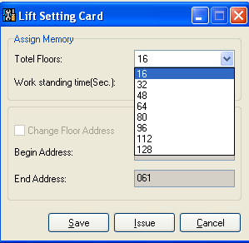

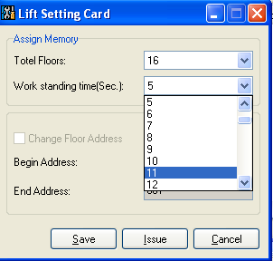
After confirming all information, click “Save”

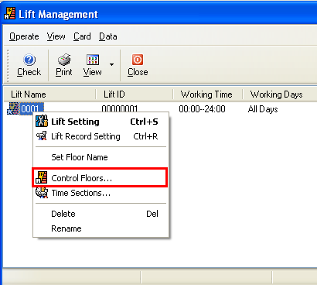
Click “Control Floors” and select the corresponding floors to control.

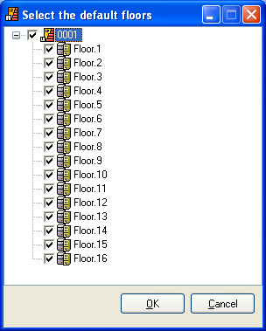

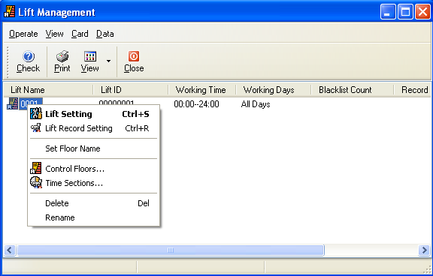
Changing the working time of lift is available.

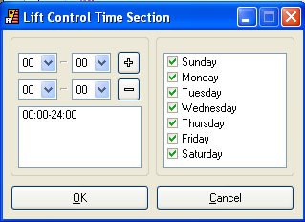
The setting is same as Time card.

Encoder installation
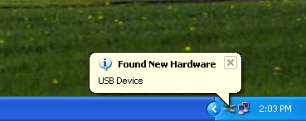
Insert the encoder, there will be a window popping up “found new hardware”, you need to install the driver.

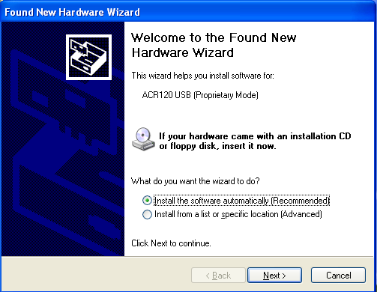

Select “install from a list or specific location”

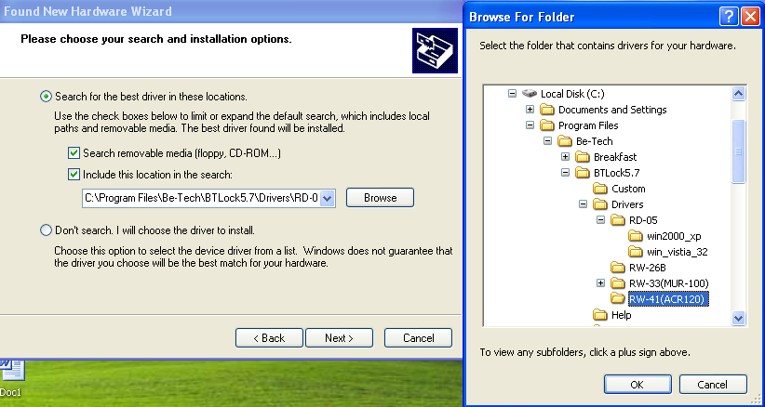

Follow the guidance to find out the RW-41 folder.

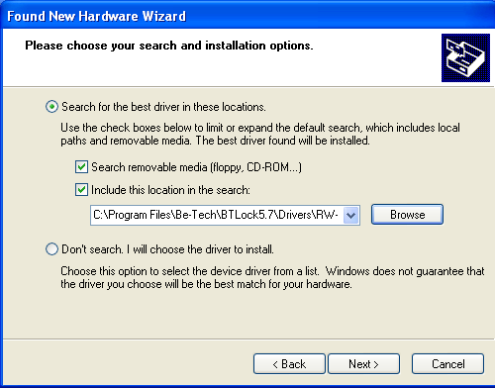

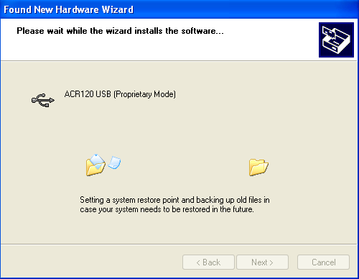

After a while, driver installs completely.

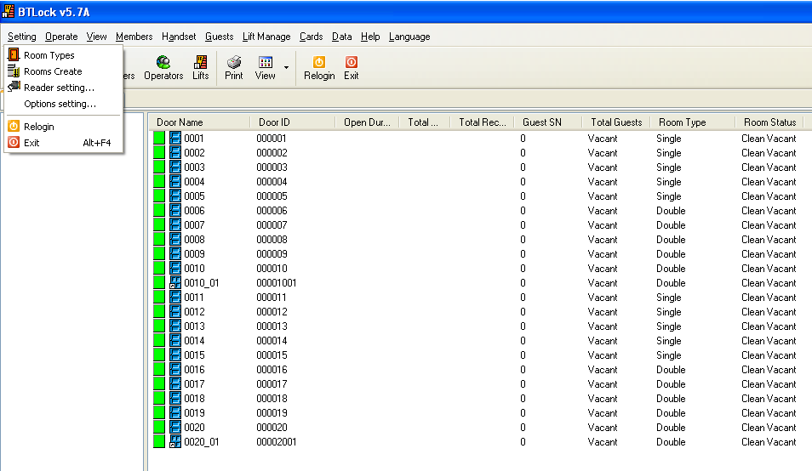
Find out “Reader setting”,

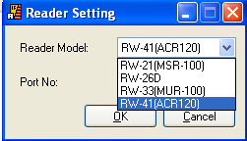

Select the corresponding encoder.

System ID card (S50)
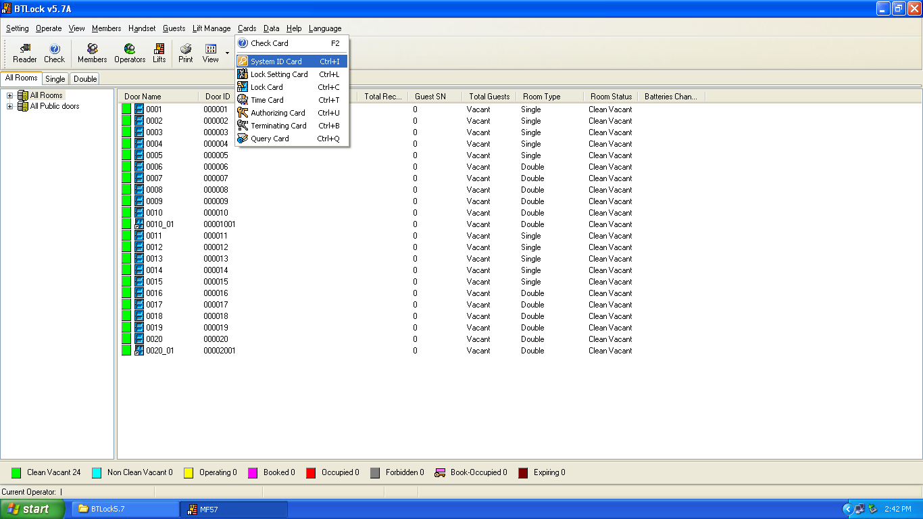

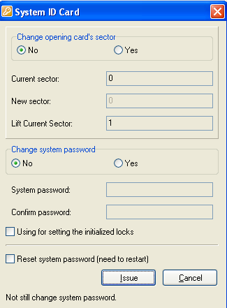

Sector
what we use for out locking system are 0.1.2 sectors, normally defaulted sector is “0” which is for locking system, “1” is for lift control system, “2” is spare sector.

Using for setting the initialized locks
It needs to be selected as the lock is reset or the lock is newly installed.

Reset system password (need to restart)
The system returns to Be-tech’s password.

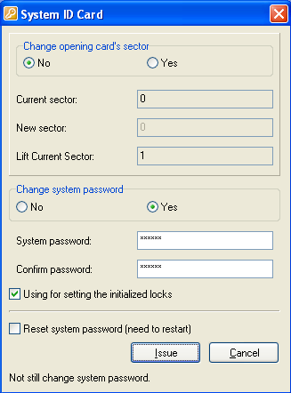
Enter 6 digits system password (numbers only), and click using for setting the initialized locks, and then click “issue”,

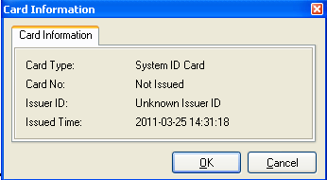
Click “OK”

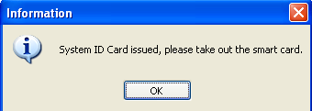

Click “OK”

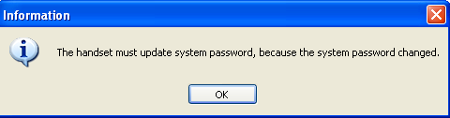

Click ‘OK”

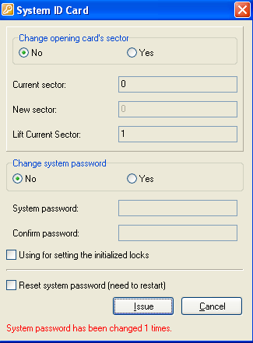
If you already changed the password, you will see red words saying “system password has been changed 1 times”, it means you have already changed the password for 1 time

Explanation of System password: Software, key card, lock, and hand held, their original system password has been set; we call it “Be-tech password”. (However, clients no need to know what the original password is).
Why we need to change the system password?
Due to there are so many clients all over the world, all locks are with “Be-tech password”, they are not safe that we can open all doors as if we keep a general card, we have to issue a new system ID card to change the system ID, then new system is no more “Be-tech password”. The system ID is changed, and all relative components must be matched with system ID so that the whole system is working.
How to get the SID if you forget:

Lock setting card (S50)
Lock setting card is used for setup lock’s information, such as lock number, lock memory, motor parameter.

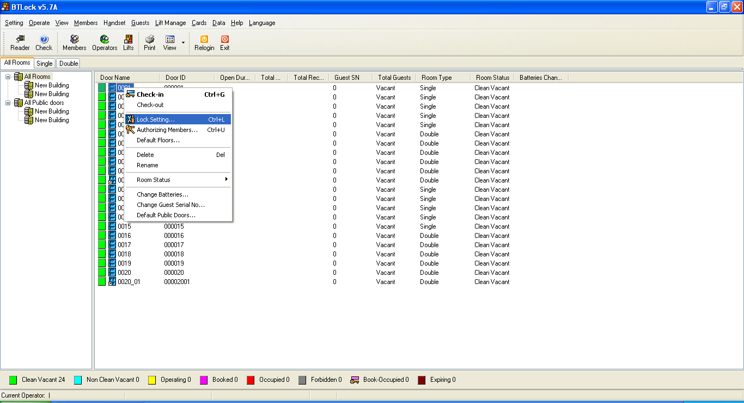
Select one room, right click and find out “lock setting”

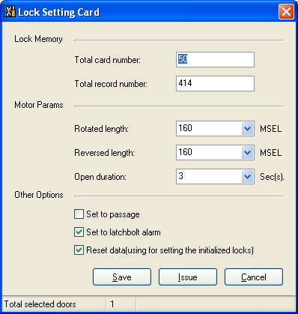

Lock memory
It is used for setting up staff card and access records’ amount. Total card number is for staff card amount, the defaulted value is 50, you can change the amount depending on your staffs, but the amount would better no more than 100, because the amount is larger, the card scanning time is longer.

Motor parameter
It is for setup mortise parameters, no need to change them.

Set to passage
Passage means the lock won’t lock automatically after unlocking.

Set to latch bolt alarm
Latch bolt alarm is for avoiding door does not close well. If latch is hanged, lock will sound “Be, Be…….”

Reset data (using for setting initializing locks)
Reset previous records and data, such as access records, guest SN, staff card amount…..

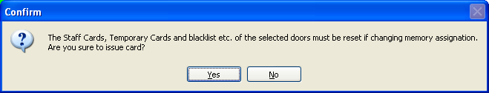
Click “Yes”

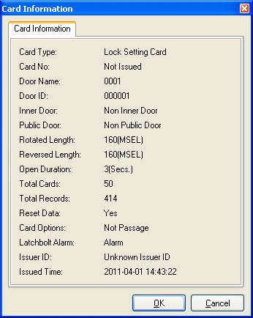

You can see all information before you issue the card

Click “OK” to issue card.

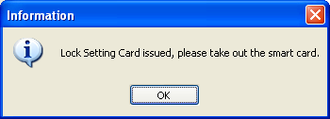

Click “OK”

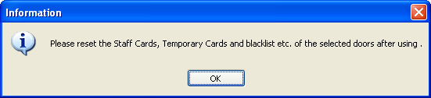

Click “OK”

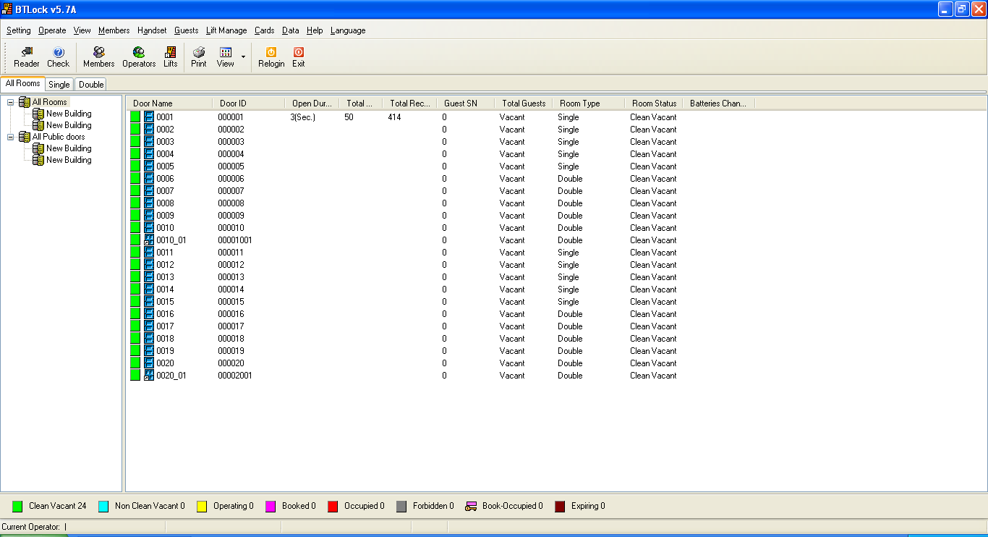
You can see lock’s information displaying.

Note: If you have 100 rooms, you have to issue 100 times lock setting card, because every door with different room NO., we have to issue different cards to set up different rooms. However, 100 times is not meaning 100 cards, you can issue the lock setting cards with only 1 card. For example, you already issued the lock setting card for room 000001, and then take the card to scan the door, 1 beep, green light, setting is OK, and at this time the room is 000001. To setup room 000002, we can use a new card or the 000001 lock setting card, after issuing, the door ID would be changed 000002, at this time the lock setting card is 000002. And then scan the door, 1 beep, green light, setting is OK, and the door ID is 000002. Even though the previous ID is 000001, after scanning the ID 000002 and the door will change into ID 00002
If you use handset, you can select all rooms and click “locking setting card”, and then click “Save”, you will see all rooms have been set.
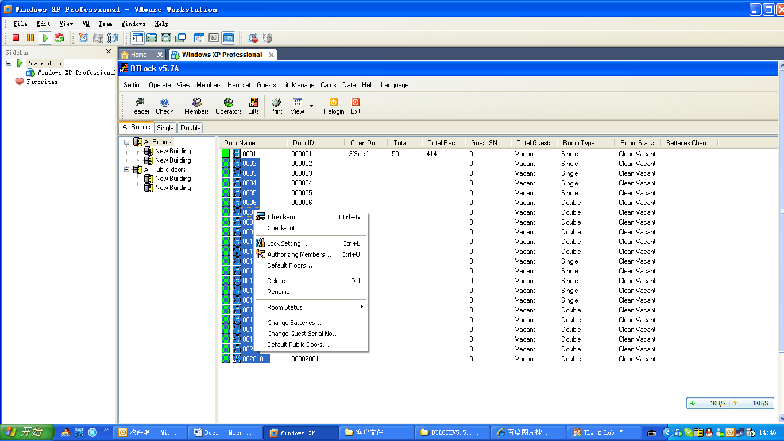

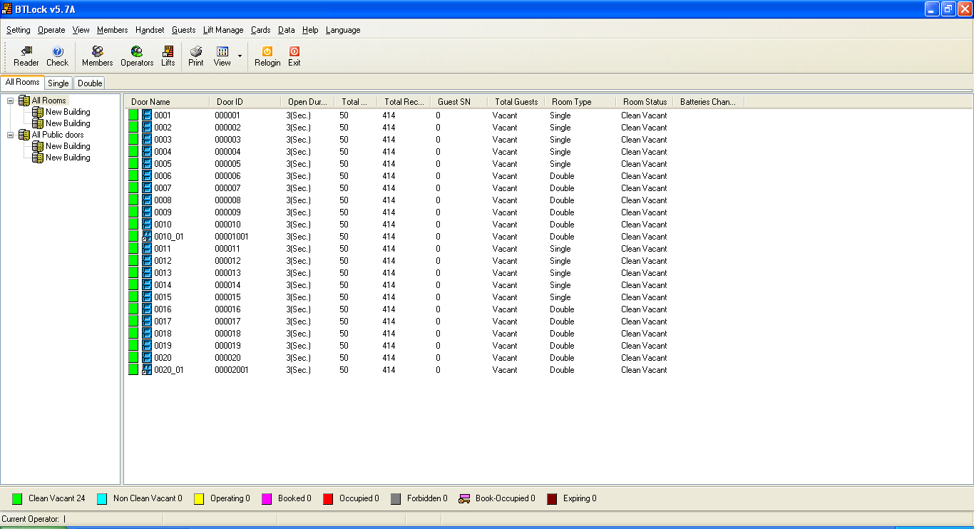

Public door setting (S50)
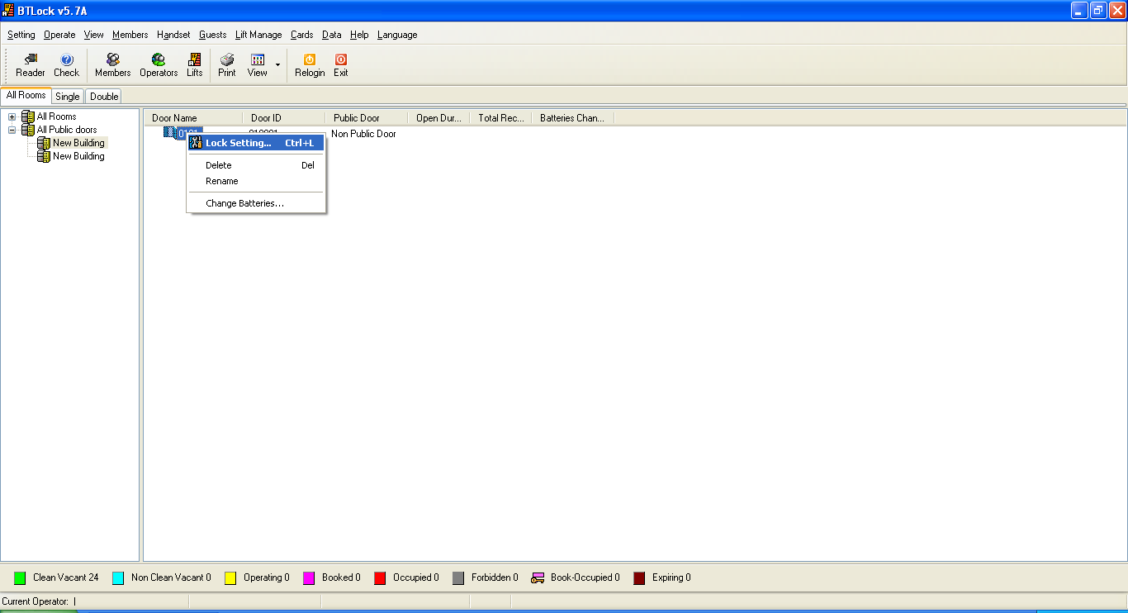
Choose the door and right click, click “lock setting card”

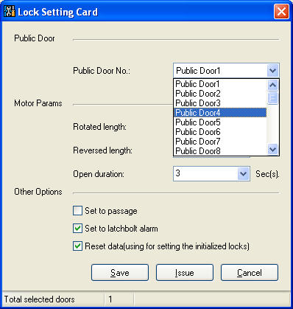

There are 32 public door groups, one group with max 16 rooms.

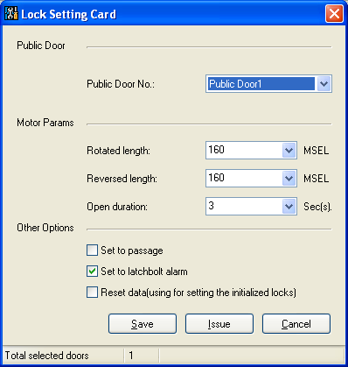

If you use handset, click “Save”, or you need to click “Issue” to setup the lock.

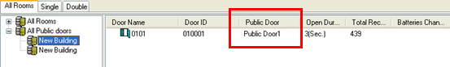

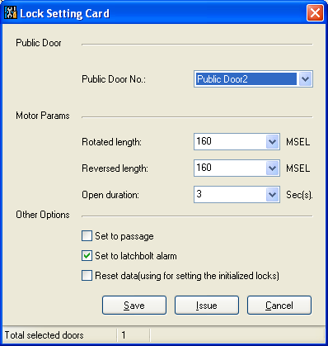

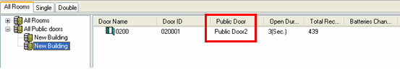

Lift setting (S50)
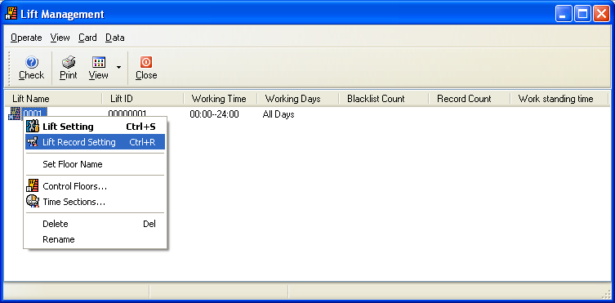
Lift record setting: used for setup lift’s blacklists and total access records

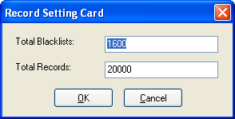
You can change the values of blacklists and records

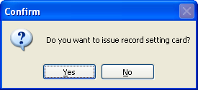
Click “Yes”

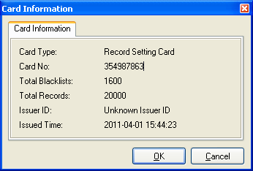
Click “OK”

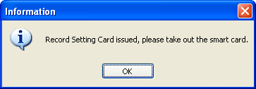
Click “OK”

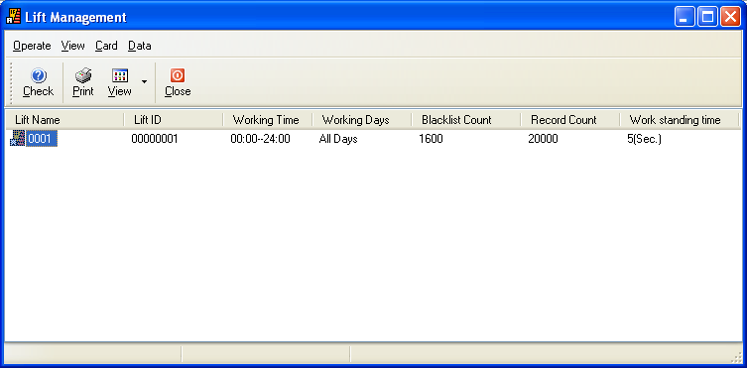

Take the record setting card to scan the reader, 1 beep, green light, setting is completely.

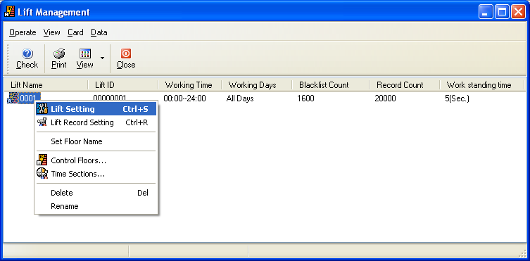

Issue lift setting card:

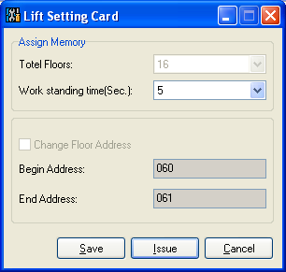

Click “Issue”

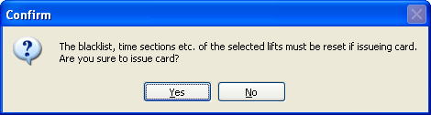
Click “Yes”

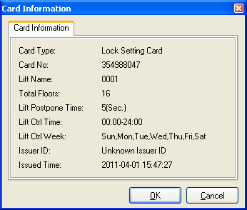
Click “OK”

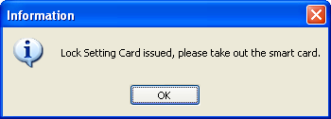
Click “OK”, done.
Take the setting card to scan the receptor, 1 beep, green light, setting completely.

Emergency cards (S50)
Emergency cards: it can open the door without any limit.
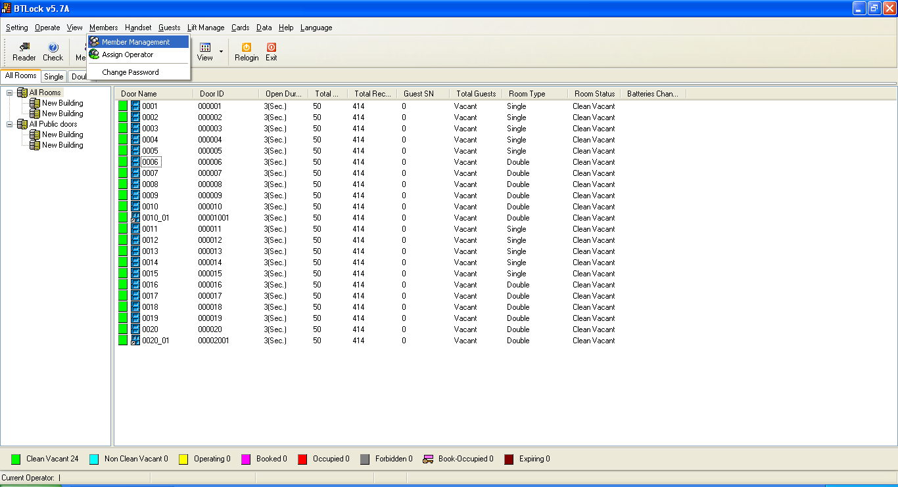
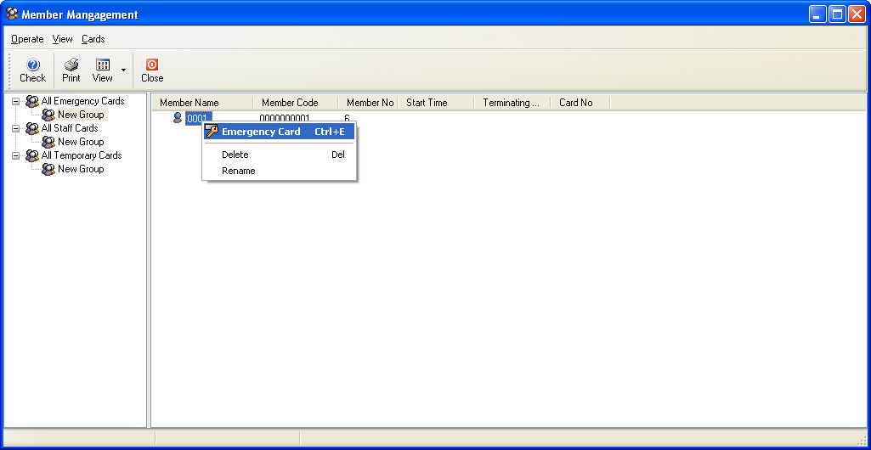
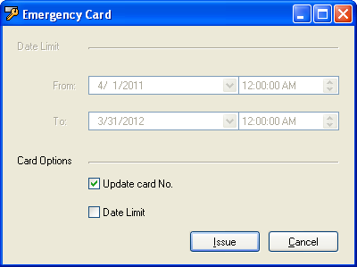

Update card No.: if the software is newly installed without and data, so the option is chosen as default. After issuing, there will be a card NO.

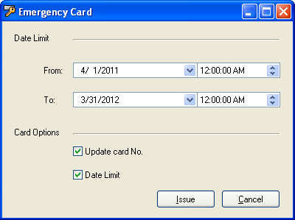

You can select emergency card with date limit, it means that emergency will be controlled by time;

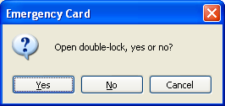
,

Click “Yes”

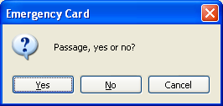

Click “Yes”

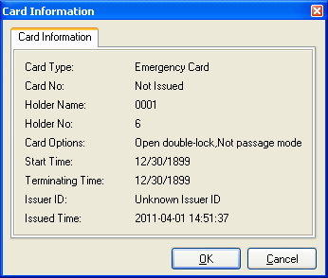

Click “OK”

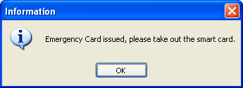

Click “OK”

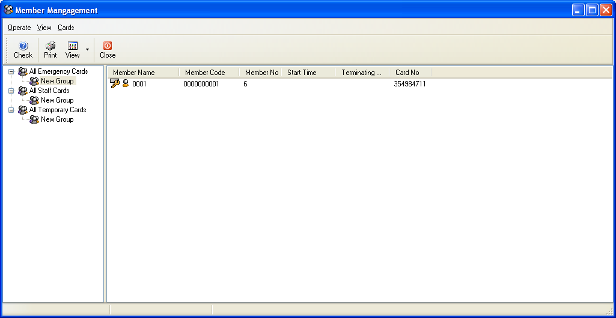

Staff card (S50)

Issue staff card
Before issuing staff card, you need to setup staff’s working time section.
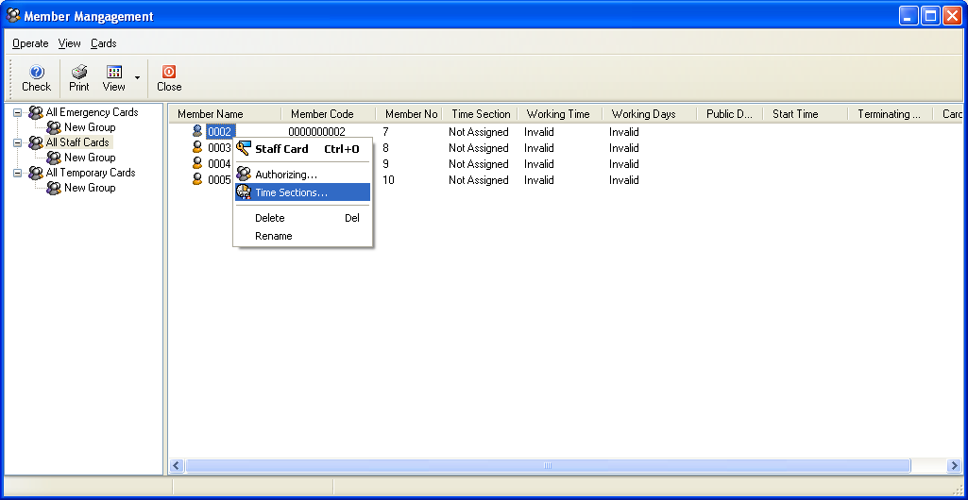

Right “Click”

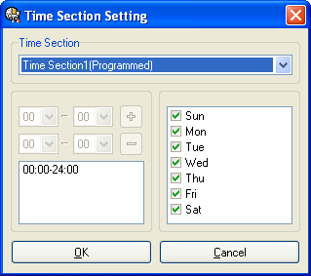

This time section is already set in time card.

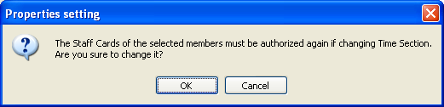

Click “OK”

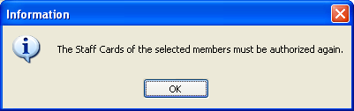

Click “OK”

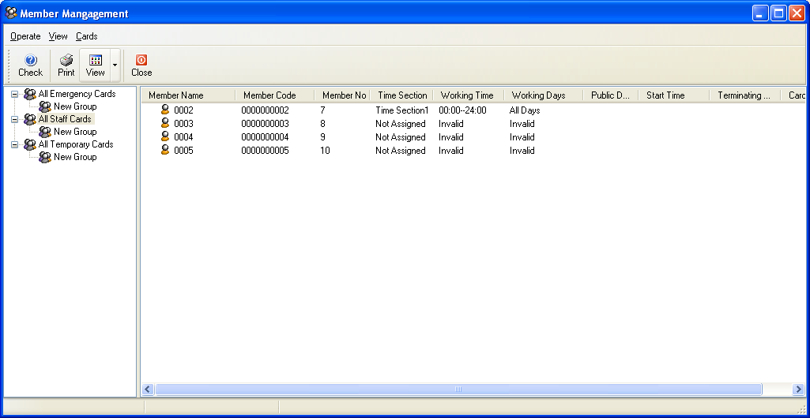
You can select all staffs to setup the time section if they are in a same work

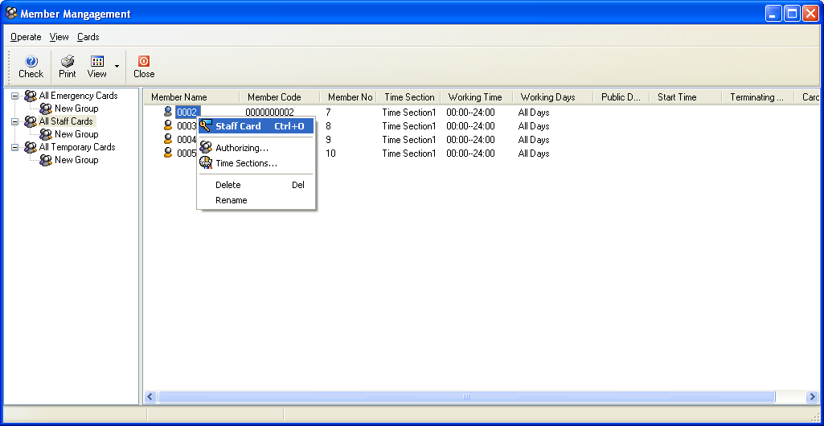
Then we move to issue
“Staff card”,

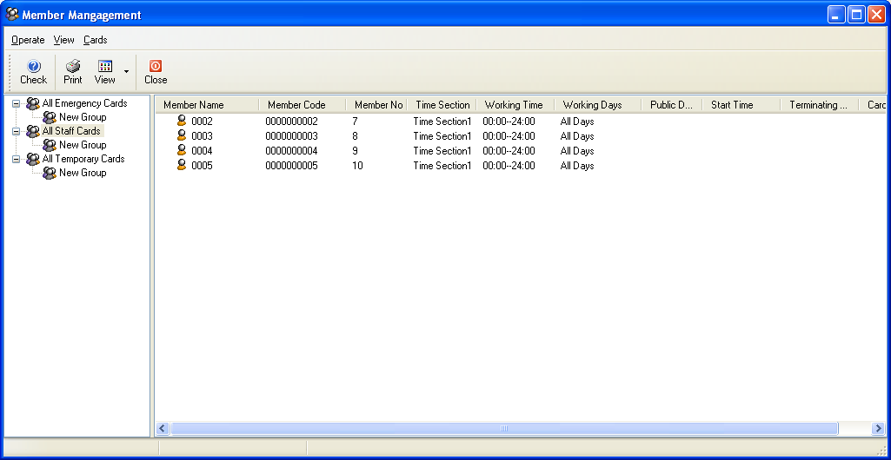

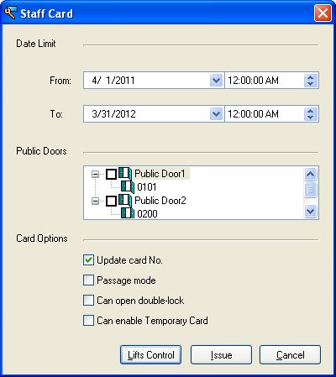
You can choose the corresponding public door, lifts, enable temporary card before issuing staff card. (Can enable temporary card: it is for temporary card’s available time, it has to be programmed by staff card)

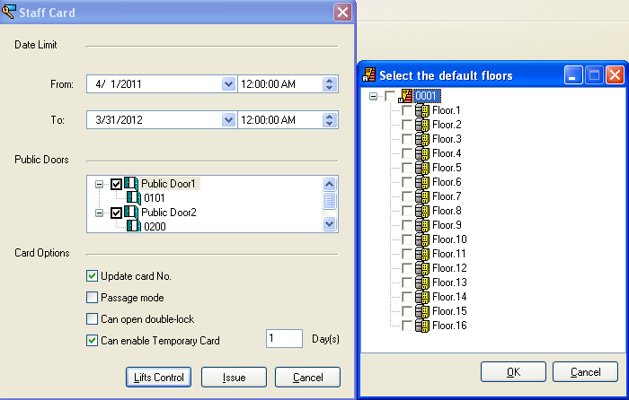
Click “lift control”, there is a window to select the avoidable floors.

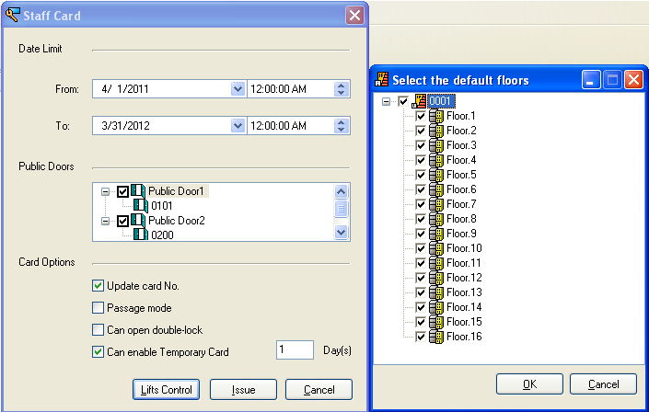

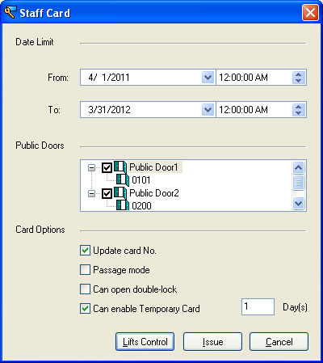

Click “Issue”

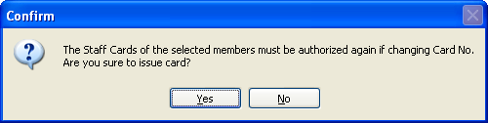

Click “Yes”

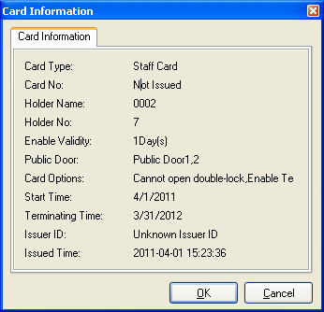

Click “OK”

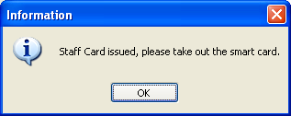

Click “OK”

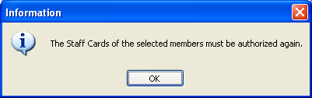

Click “OK”

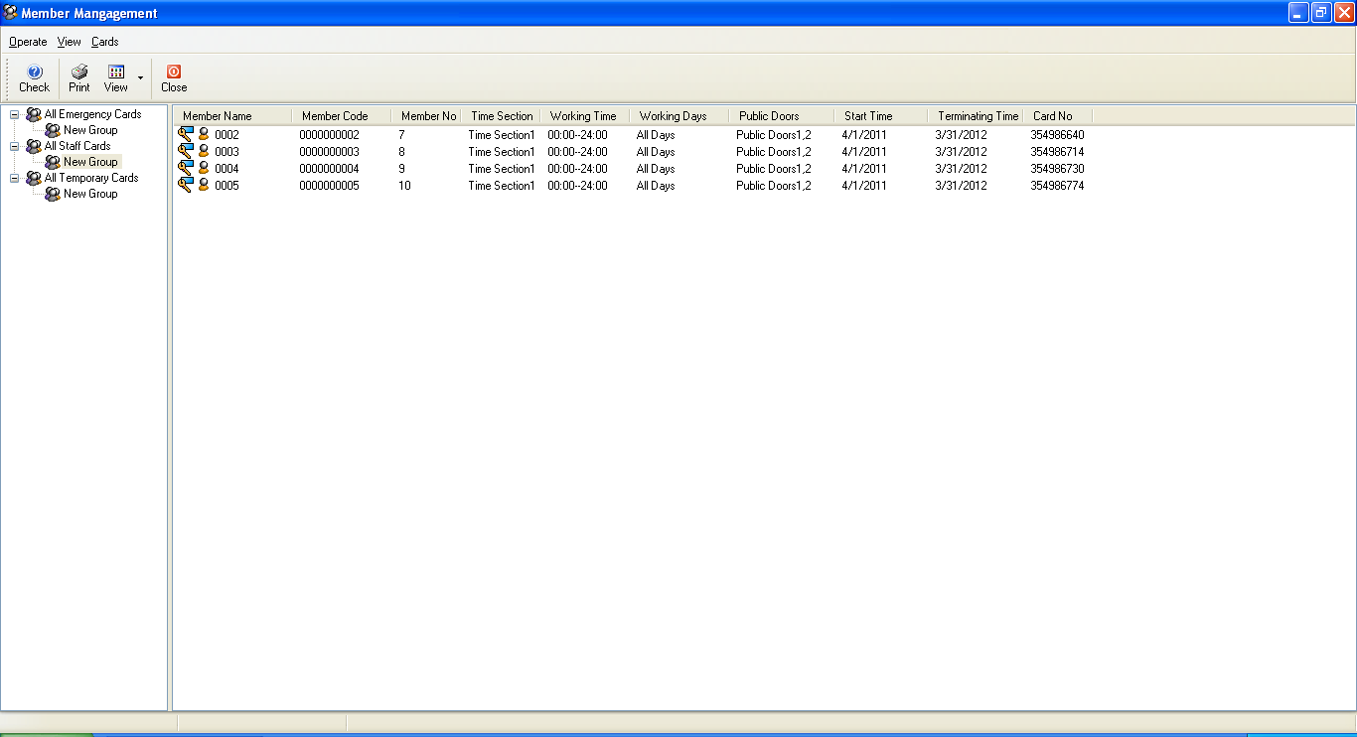

However, card can’t open the door right now; even you already issued the card.

Authoring staffs
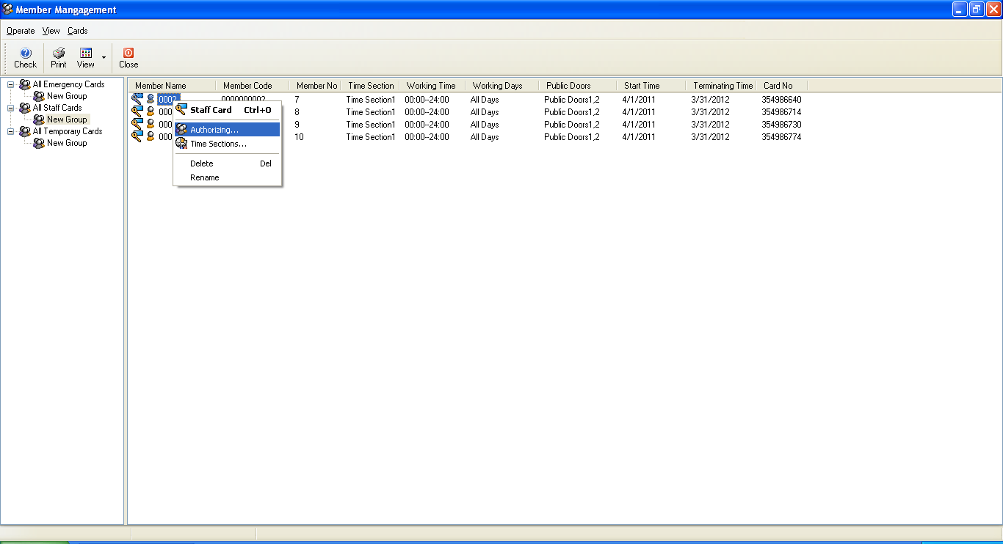
Right click and choose “Authoring…..”

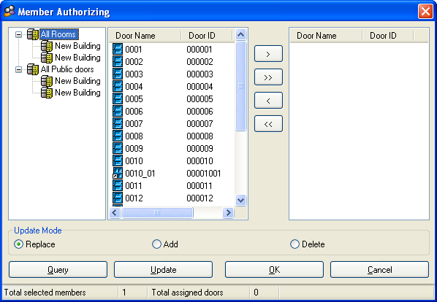
You can see all rooms on the left.

.
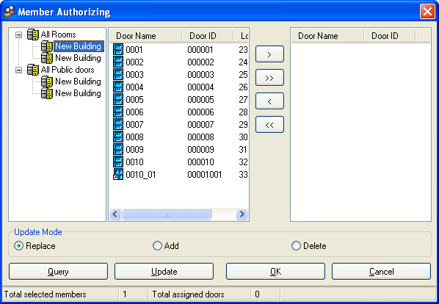
If you want to have a staff can open room 0001 to 0010, you need to choose rooms and move them to the right

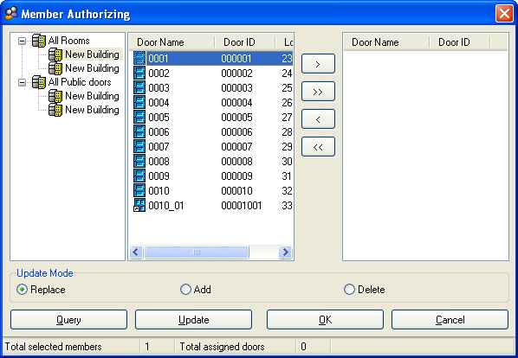

Choose corresponding rooms and click “” to move them one by one

Or you can click “” to move all of them.
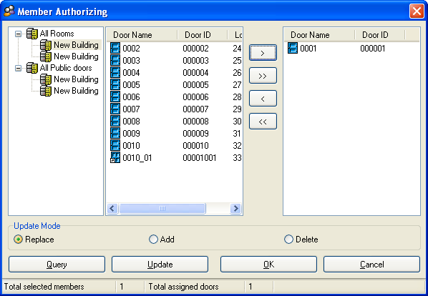

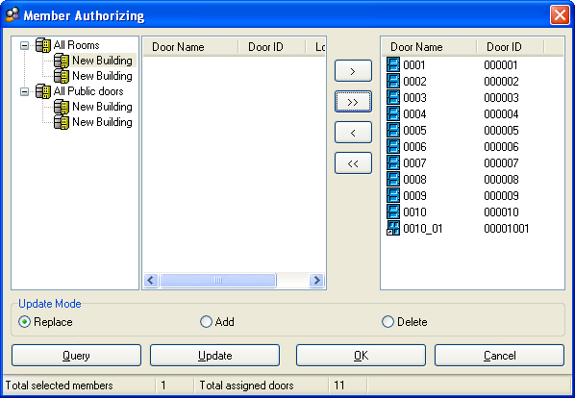

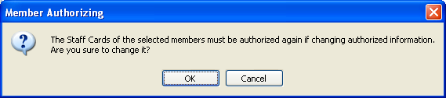

Click “OK”

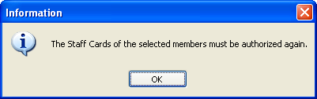

Click “OK”

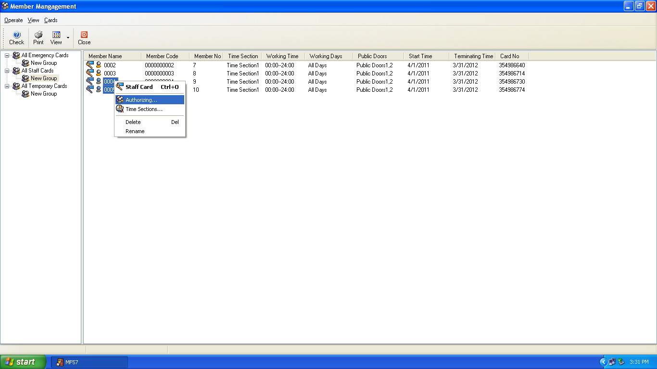

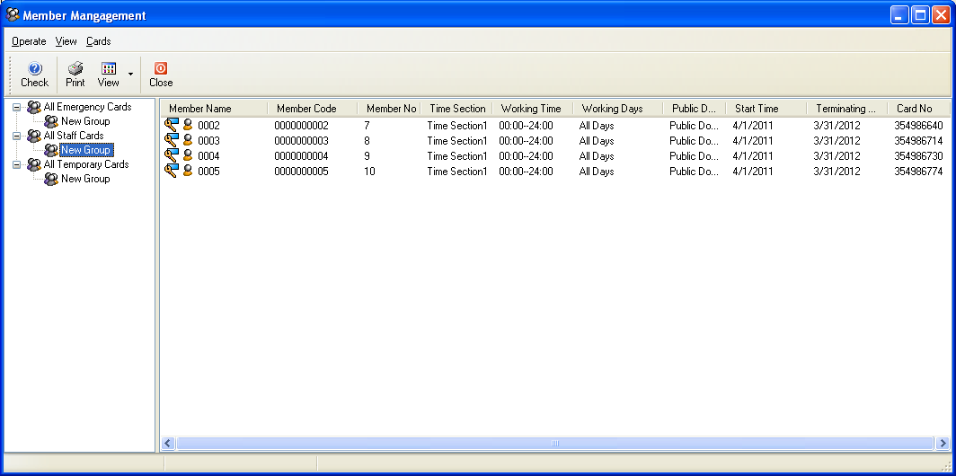
You can choose the persons that have same authorization to authorize

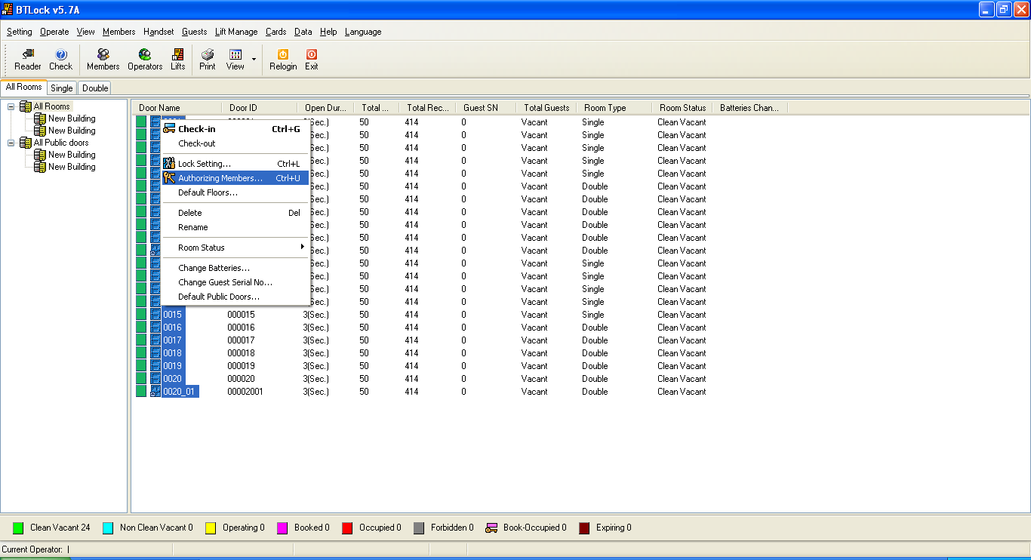
Then, go back to “All rooms”, choose all rooms and right click, find out “authorizing members” and click, you will see the members under the rooms, it means the one can open the room.

.
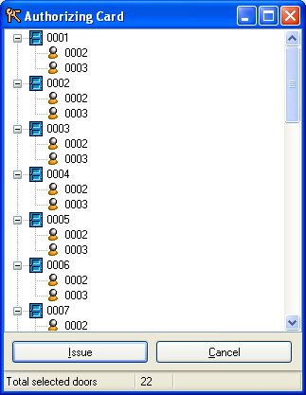
However the staff card can’t open the door right now, ever though you have issued the card, so you need to issue authorizing card to scan the door, after that the staff card can be used. Please find out the authorizing card

Issue “Temporary card” (S50)
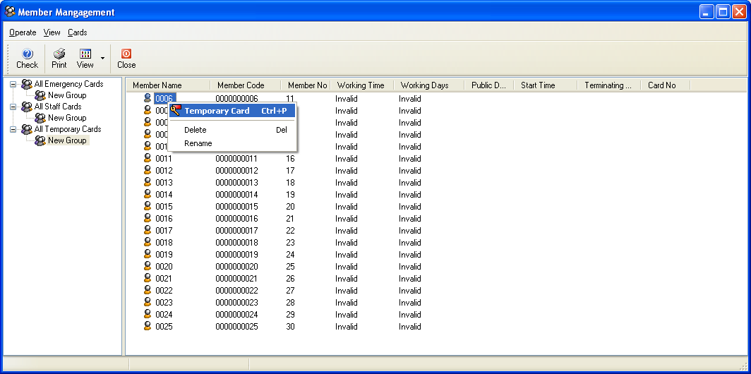
Right Click or double Click

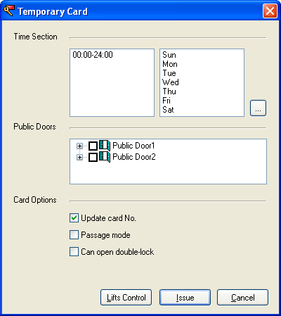
Select the time sections and other options, and them click “issue”

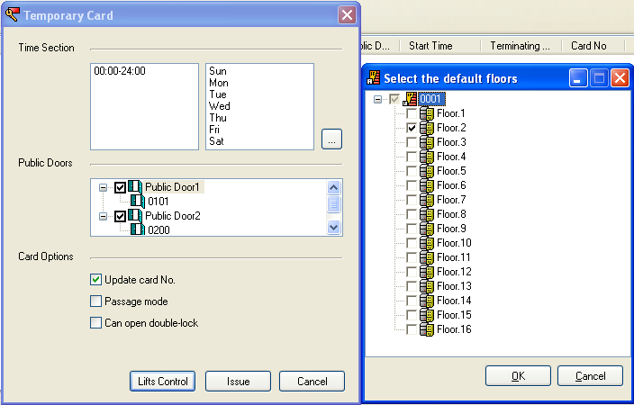

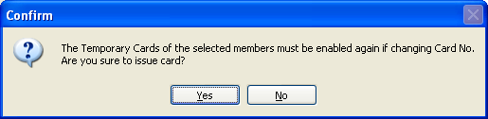
Click “Yes”

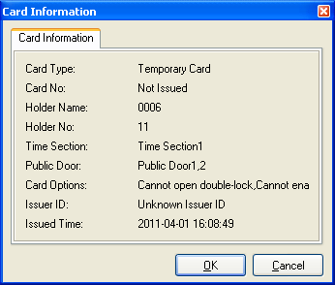

Click “OK”

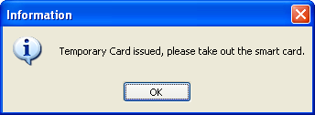

Click “Yes”

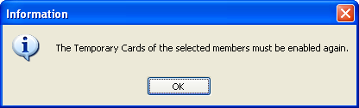

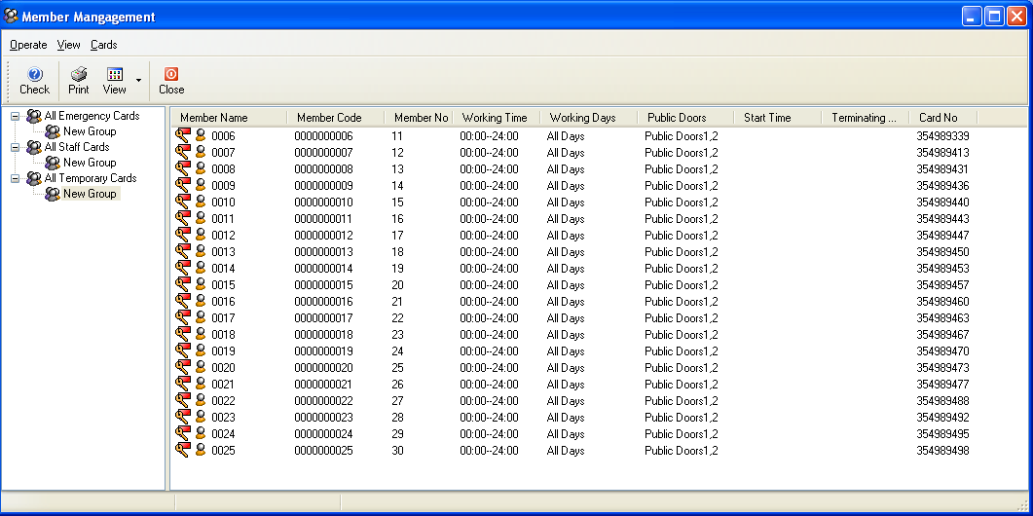

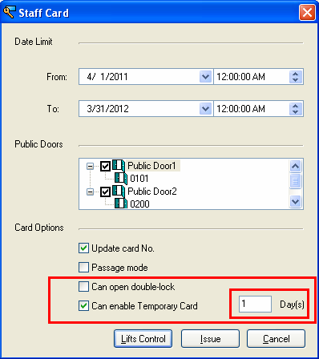
Note: Temporary card can not be used directly, it need to be programmed by staff card that contains “can enable temporary card”. The available time for the card depends on how many days you choose when issue staff card, time beginning is since the time you program the temporary card by staff card.

Authorizing card
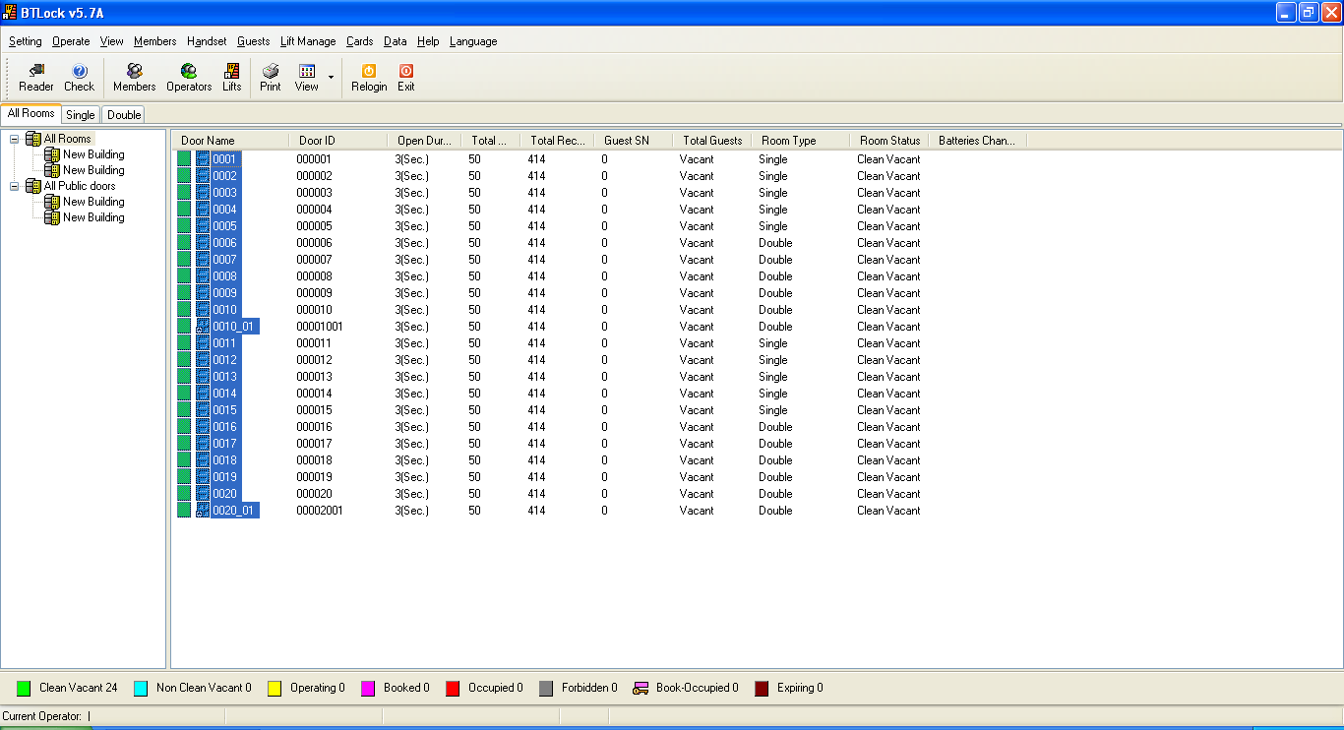

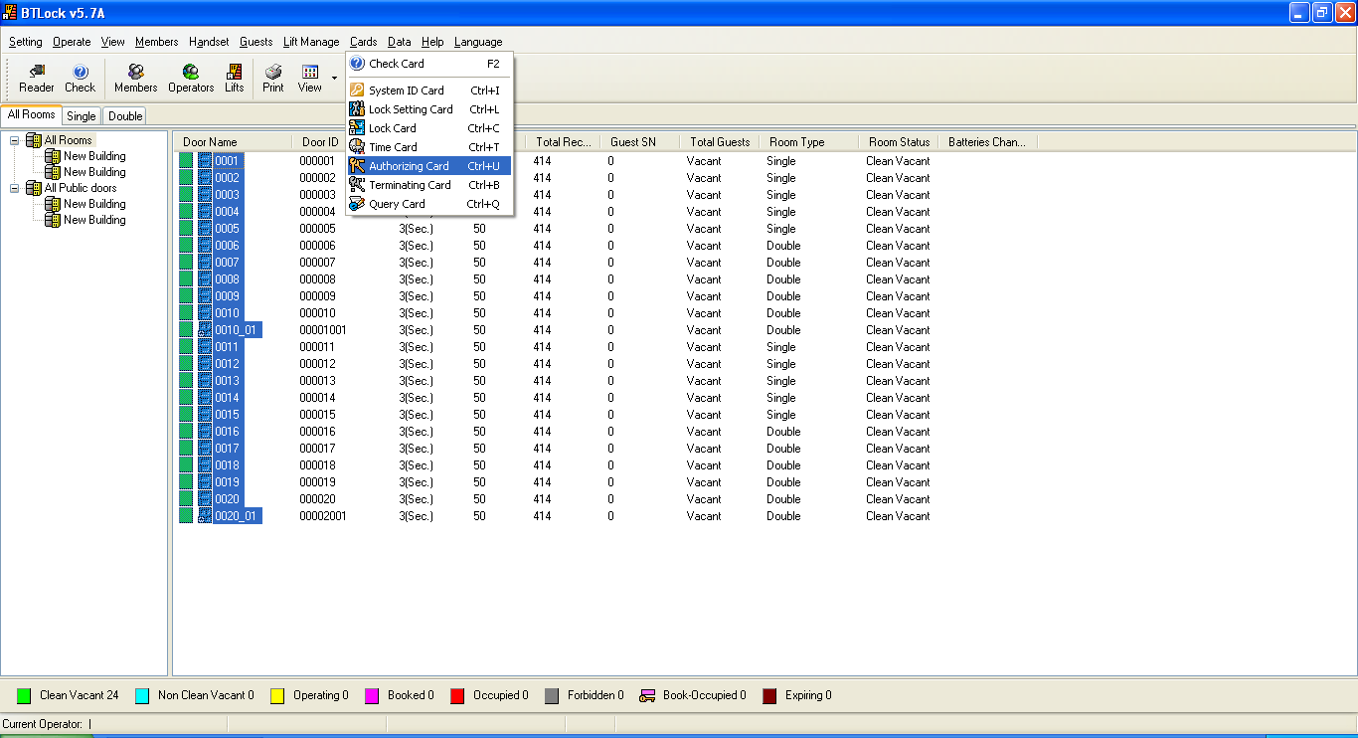
Select the rooms find out “Authorizing card”, you will see the window shows as below.

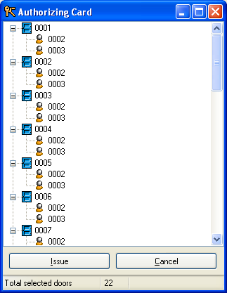

Click “Issue”, and take the card to scan the door,

Assign member (Operator log in)
You can setup operator’s permission

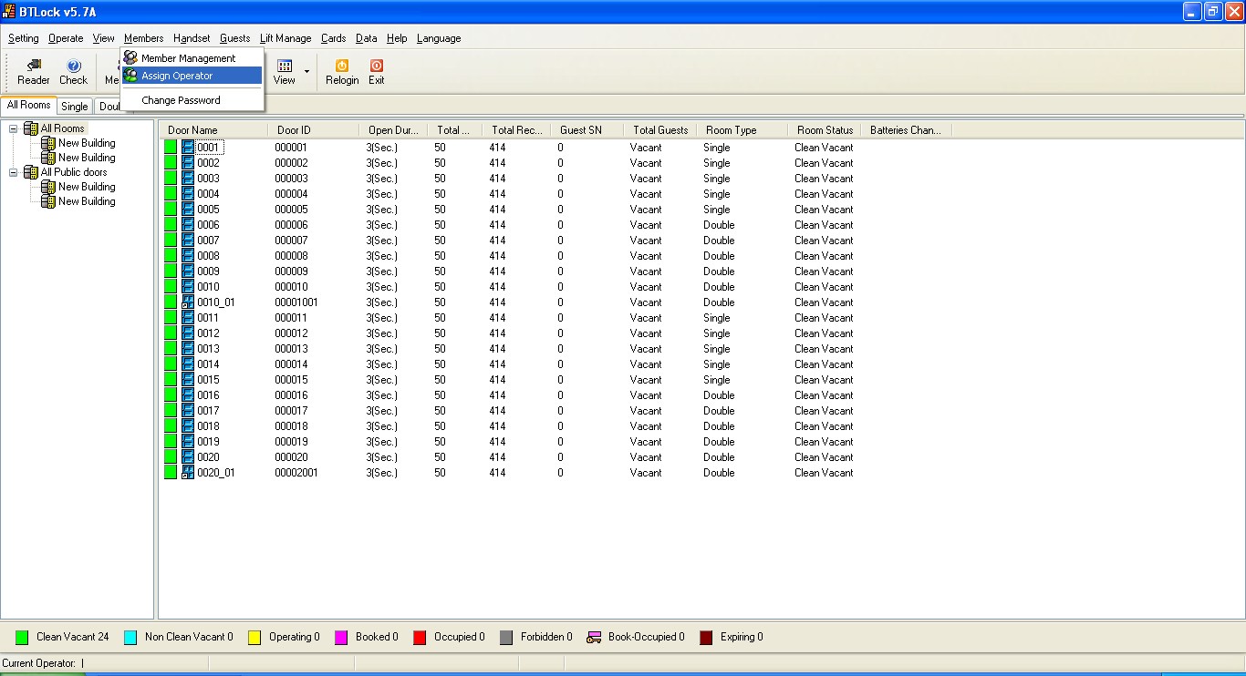

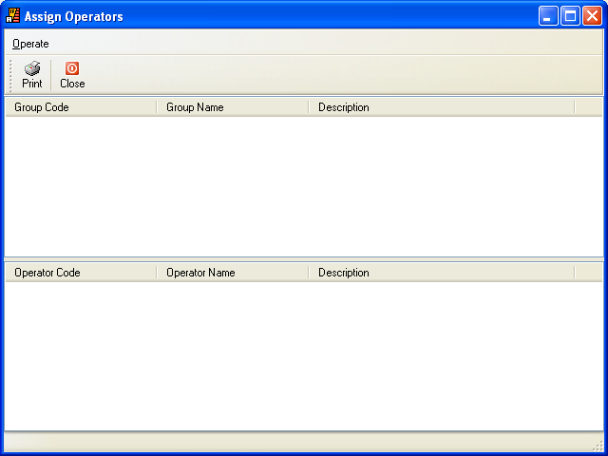

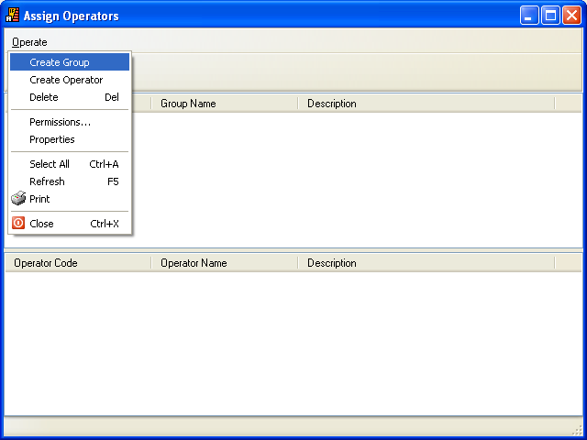

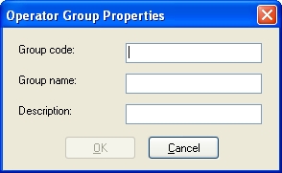

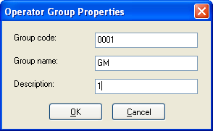

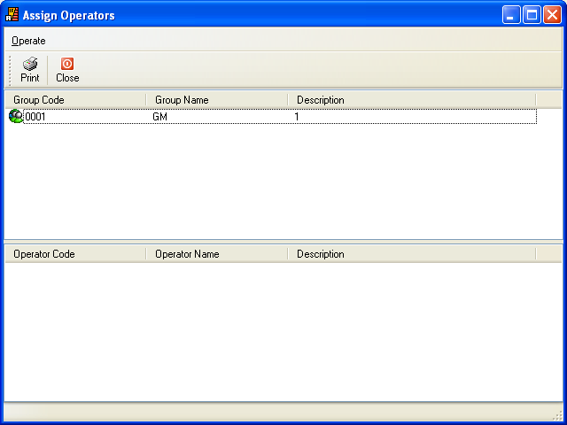

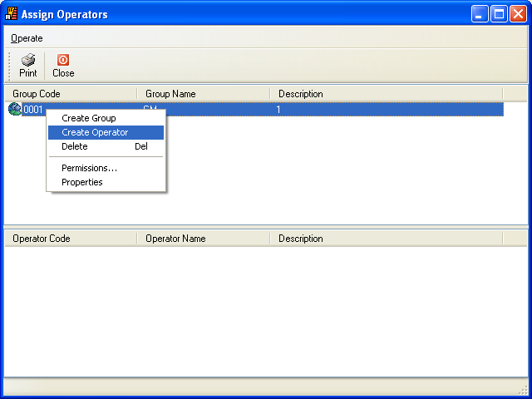

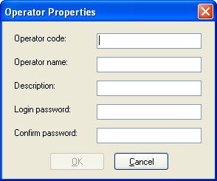

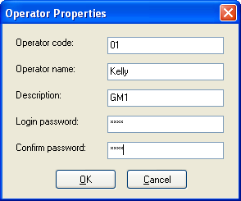

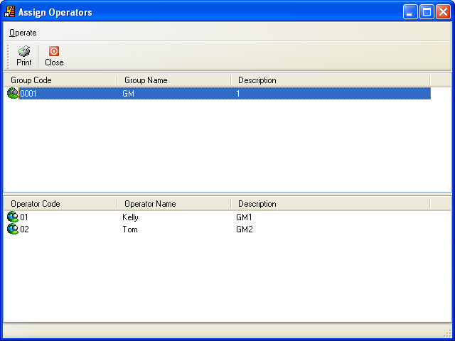

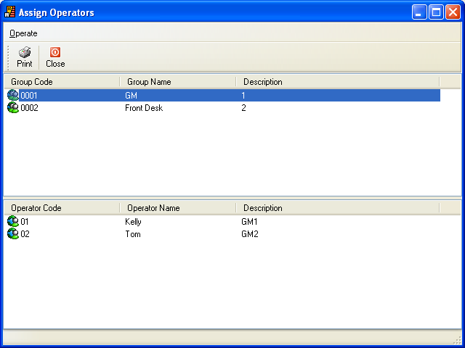

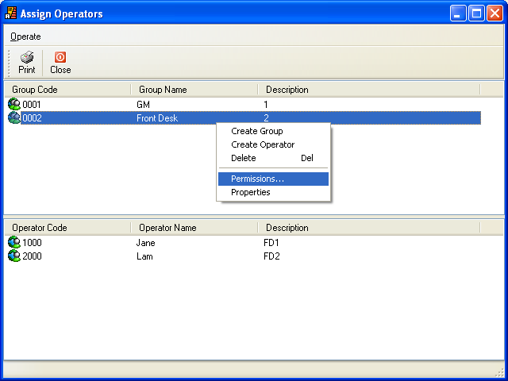

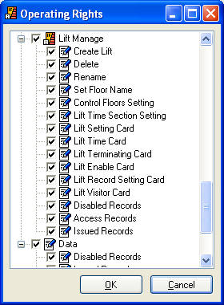

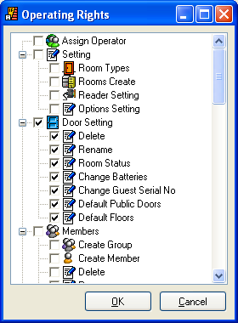

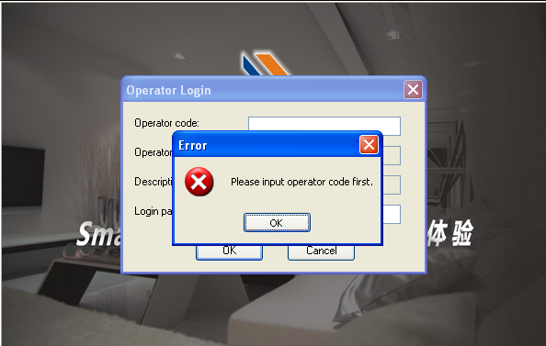

You have to enter operator code and login password to access software.

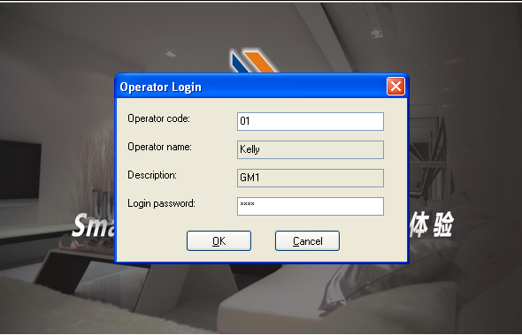

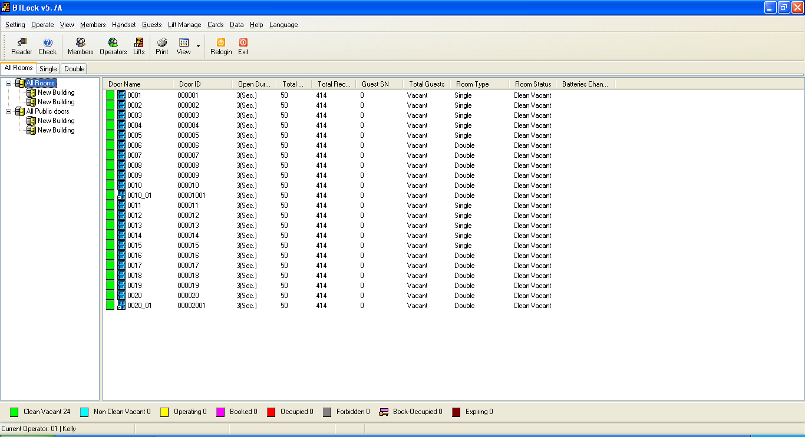

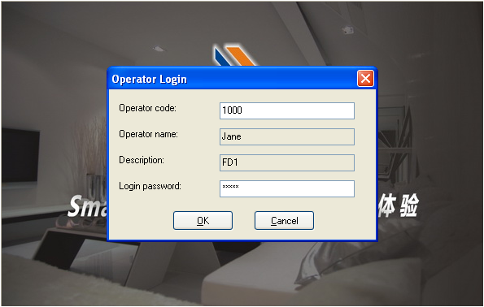

When you enter the operator that with permissions, so you will see there would be some options you can’t run.

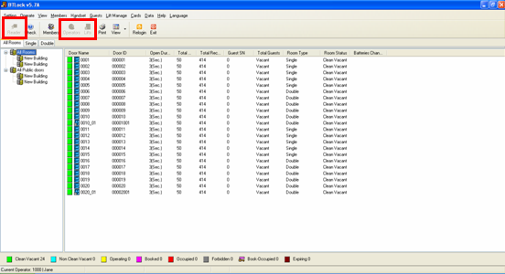

Terminating card (S70)
If you loss key card, and you want to terminate that card to open doors, so you need to issue terminating card.
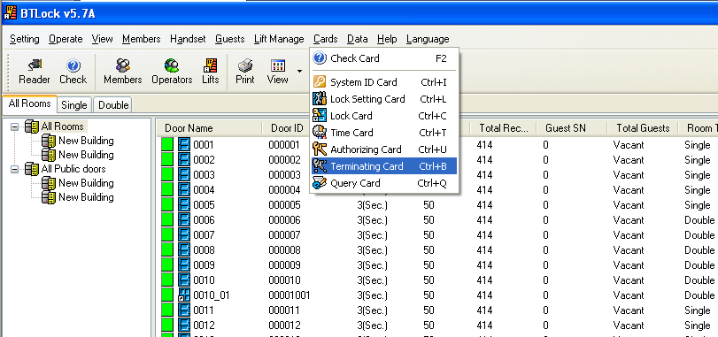

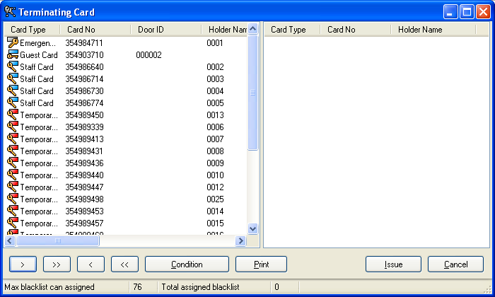
.

On the left, there are the cards that you already issued, once you loss some of them, choose the lost one and click , make it move to right, and then click “”

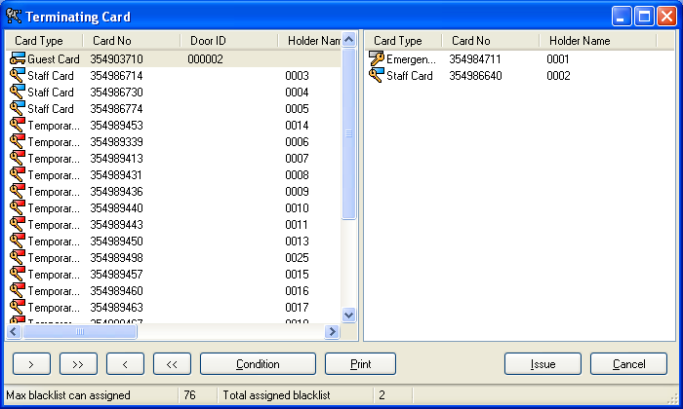

Click “Issue”

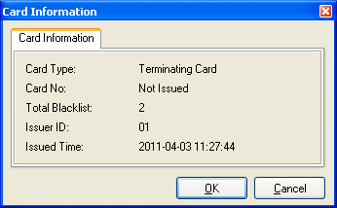

Click “OK”

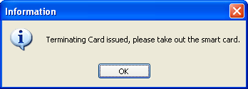

Take the card to scan all rooms, after you get “1 beep, greed light” from lock, the two cards can’t open the doors

Query card (S70)

Issue query card
There are total 3 cards need to be issue, because only one card is not large enough capacity to contain all information of lock.
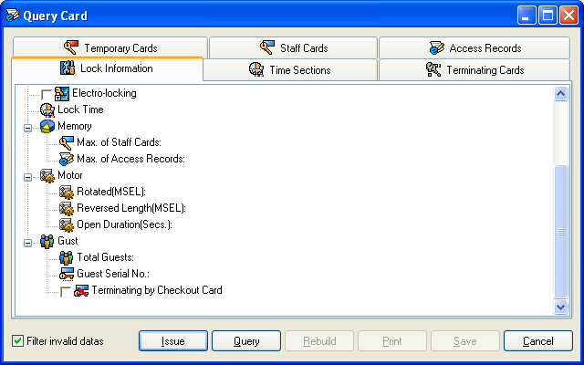

Click “Issue”

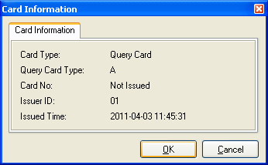

Click “OK”,

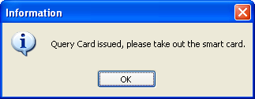

Click “OK”, in about 1 min

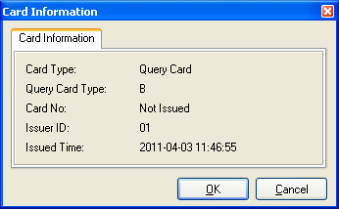

Click “OK”,

Click “OK”, in about 1 min

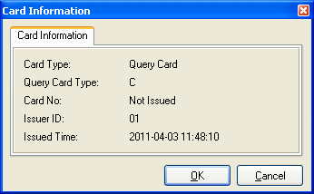

Click “OK”

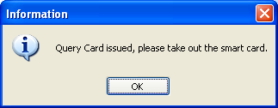

Click “OK”, in about 1 min

Take the three cards from A to C to scan the door. The lock will be “1 beep, green light” after scanning the lock meaning read data successful. However one of them is fail, please re-try again.

Read query card

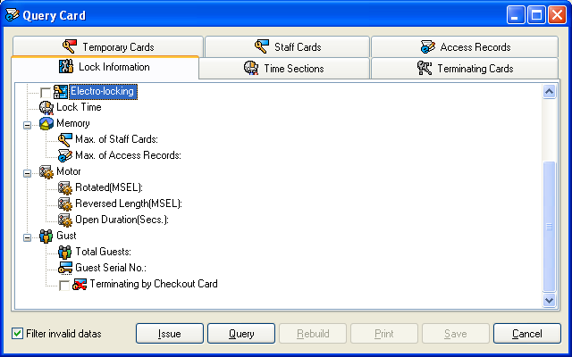

Click “Query”

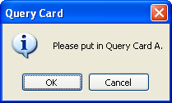
Click “OK”

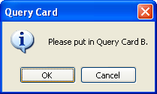
Click “OK”

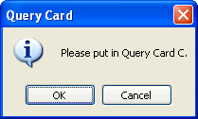

Click “OK”

Note: If one of them can’t be read, the audit trail is unsuccessful. In that case, please re-try again.

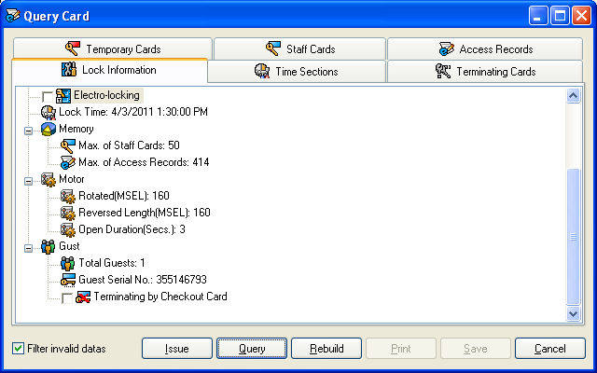

You will see the six pieces information as below,

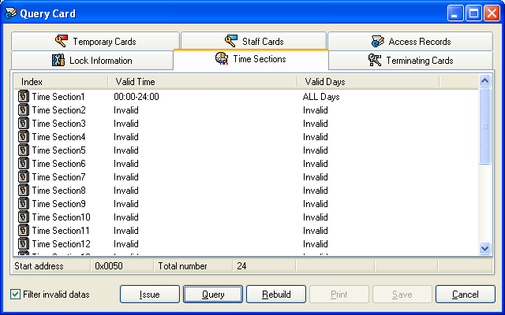

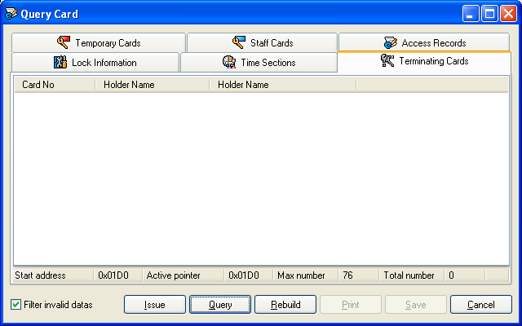

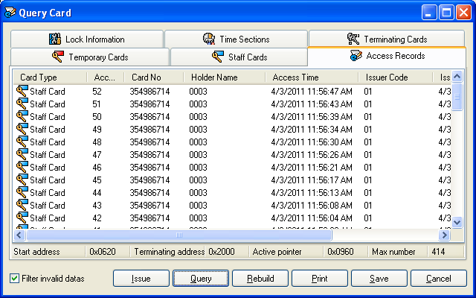

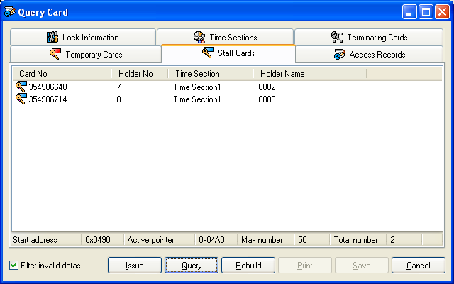

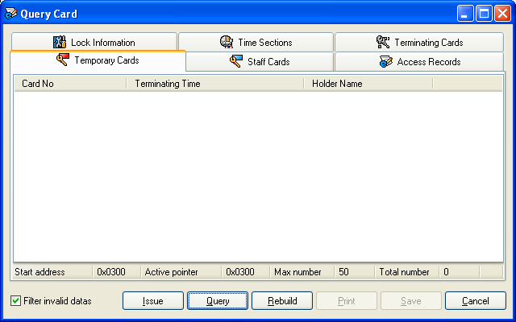

Trouble and shooting

Getting SID
Go to the Software location and find out the file showing as below:
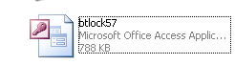
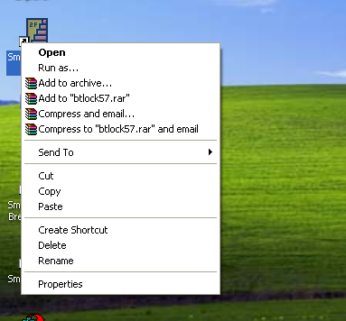

Select the icon and right click, select “Properties”

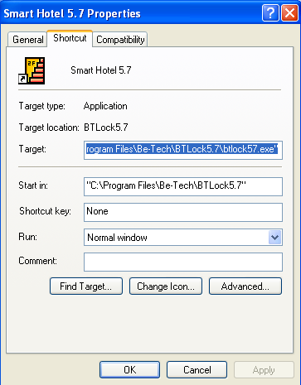

Click “Find target”

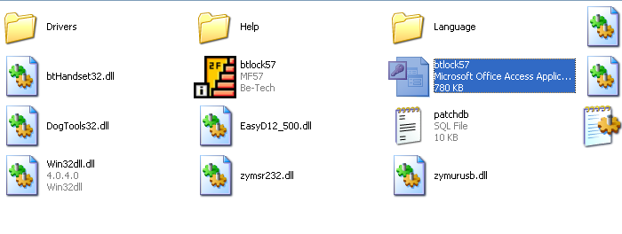
Select the file with ground color “btlock57” which is the access database, double click and open the file.

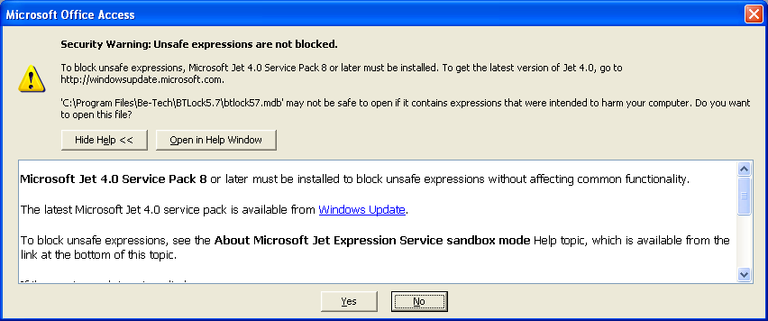
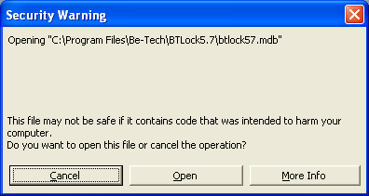

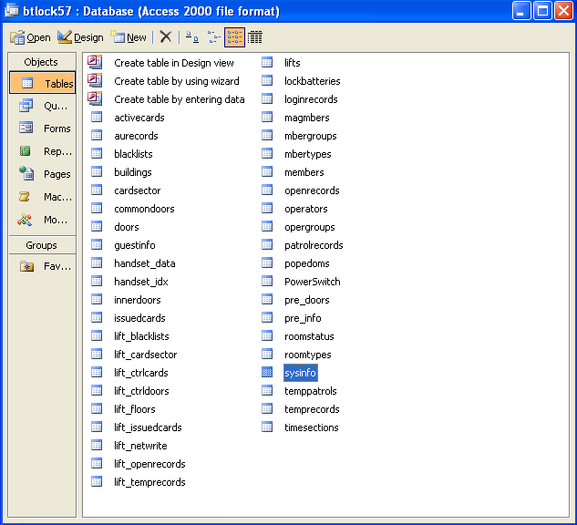
Double click “sysinfo”, you will see as below. Please give extend the form and screen shot, send it by E-mail.

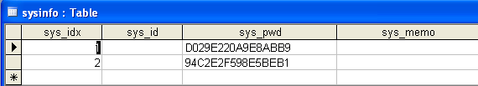

Run software occurring Error
Due to the Windows in different language, you see error “Data can’t not support by operating system” why you load the software in some English version Windows
Select the icon and right click, select “Properties”

Click “Find target”

Select the file with ground color “btlock57” which is the access database, double click and open the file.

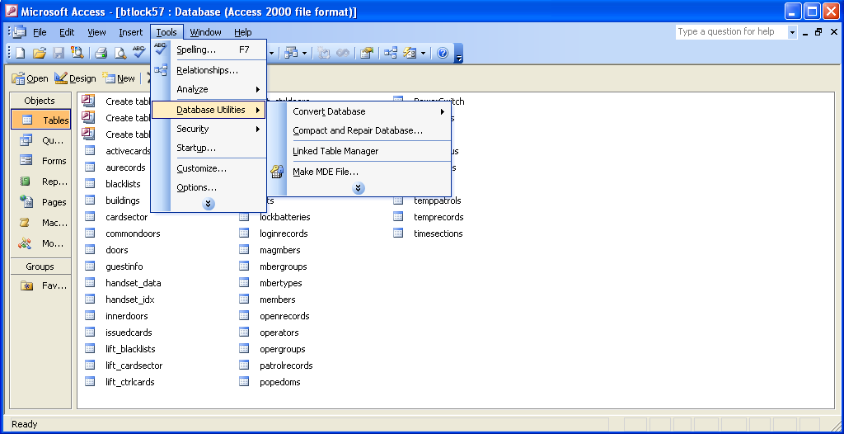
Follow the screen shot to find out the “Compact and Repair Database”

Click “Yes”

Click “Open”

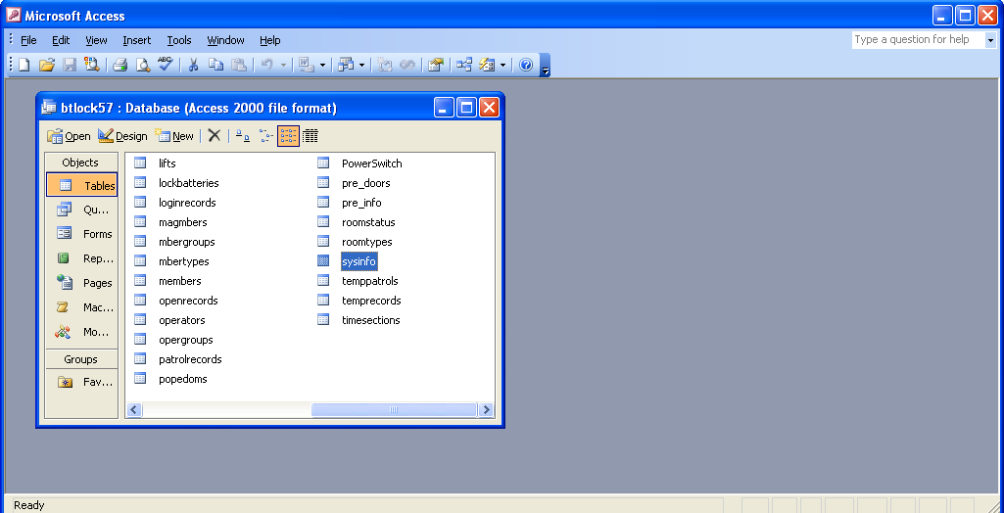
It’s OK, close the database, and run the software again.

Explanations

Setting
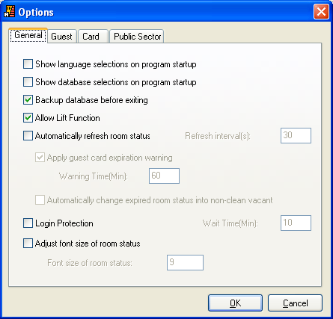
Show language selections on program startup: when you double click the icon to run the software, there will be a window to select the language. If you do not select it, it will not show as you run the software.
Show database selections on program startup: the same function as “Show language selections on program startup”.
Backup database before exiting: you will see a window telling you to backup database as you close the software.
Allow lift function: find out lift function.

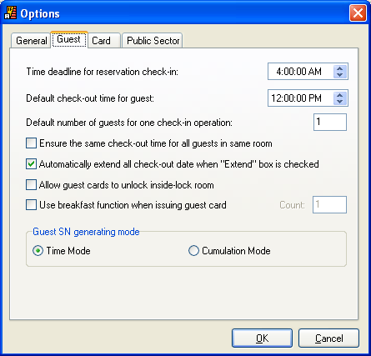

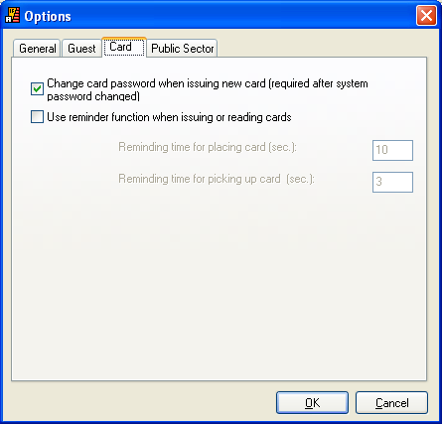

Energy Saver
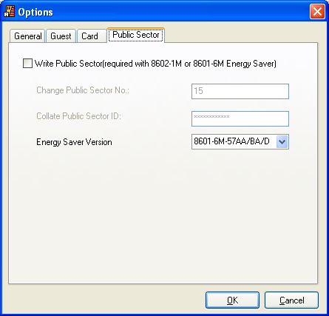

If you have Be-tech’s energy saver, you need to select “write public sector”, select the correct energy saver version, otherwise the card can’t work in energy saver.

Back up and restore database
Click “Data”
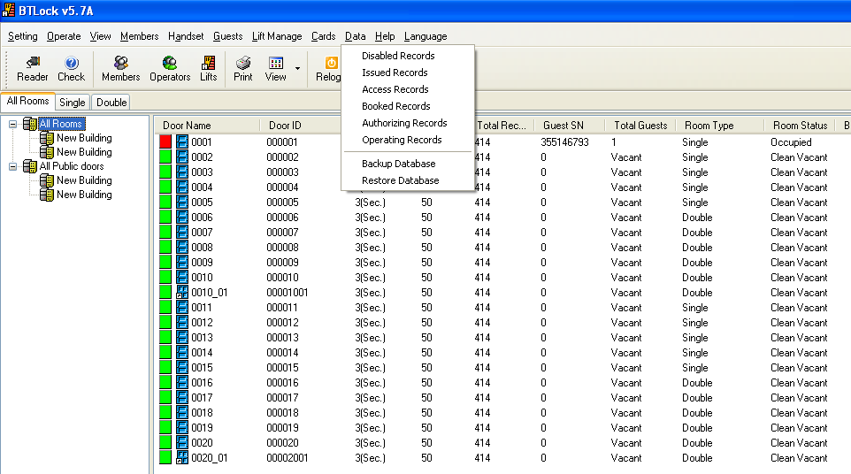

How to find out the software’s version?
Click “Help” and click “ About”,
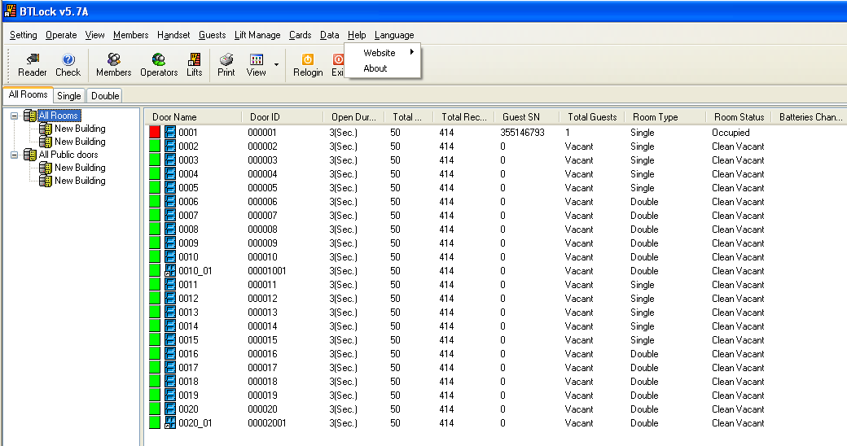

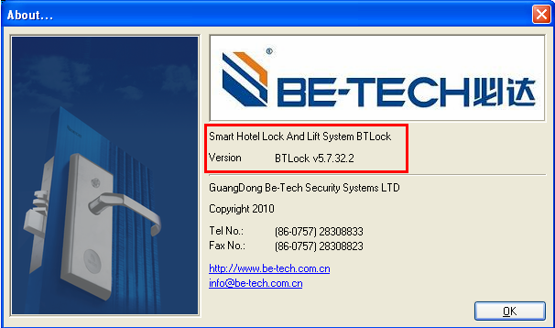

Reset SN Card
If you have the problem that emergency card, staff card can open the door, but guest card can’t, in that case, you need to issue a “Reset SN Card” to scan the lock, after one beep, and green light, the lock’s SN return to “0”.
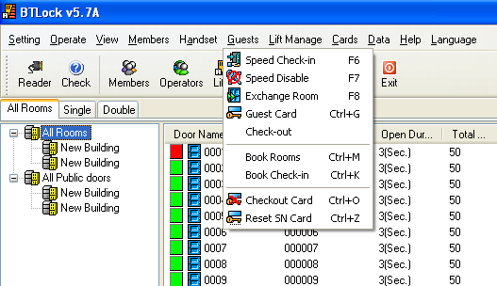

Handheld operations
First, before using handset, make sure SID card, all the rooms and members have been setup.
Second, our handheld is available for Win XP or Win Vista 32bit only, so before using that device, make sure you computer is Win XP or Win Vista 32bit.
Turn on：Press "*" about 3 seconds. After one "beep", the LCD shows entry window meaning that handheld is on.
Turn off：Press "*" about 3 seconds. After one "beep", the handset is off.
When open the handheld, there is a Be-tech logo, Press "OK" key in entry window, and then follow the indication to enter the correct password and press "OK" key for logging in.

Manus of the handheld:
- Change password of handset (change pw of handset)
- Communicate with PC (communicate with PC)
- Setup system password (setup sys pw)
- Setup lock's information (setup lock's info)
- Check lock's time (check lock's time)
- Adjust lock's time (adjust lock's time)
- Check lock's battery (check lock's battery)
- Download lock's info(download lock's information)

Install driver.
Connect the handheld to the computer, and find out the “communicate with PC, there will be a screen pops up.
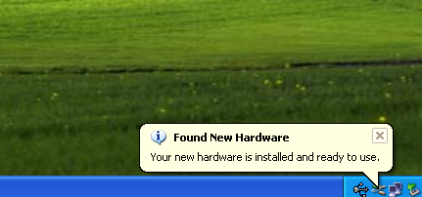

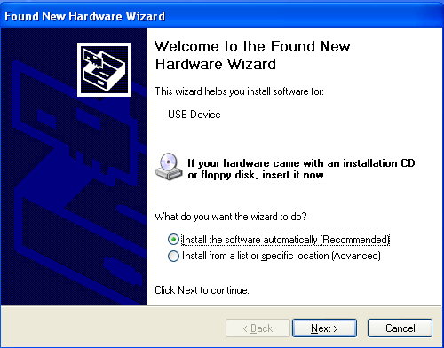

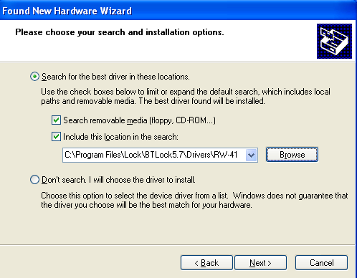

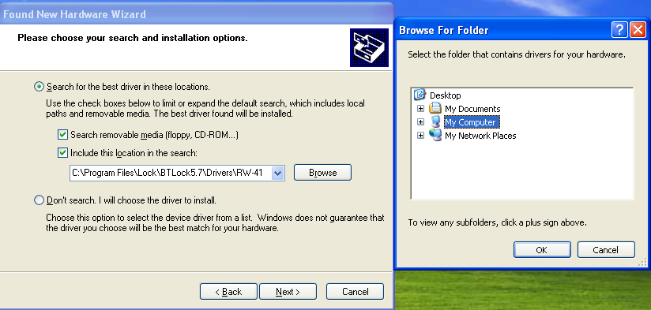

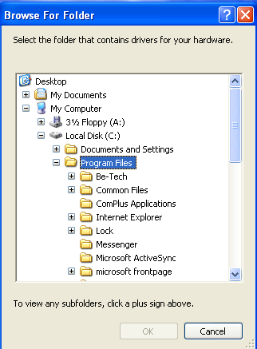

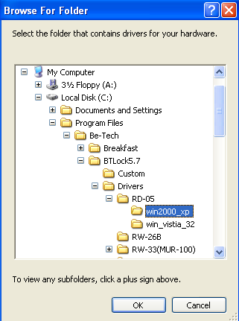

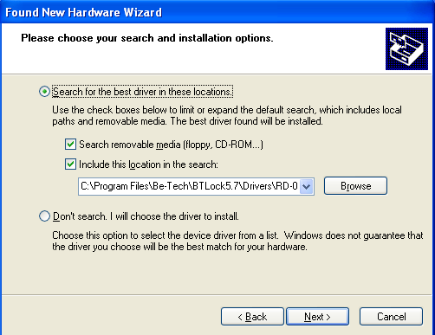

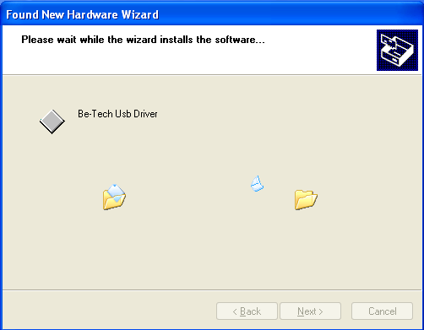

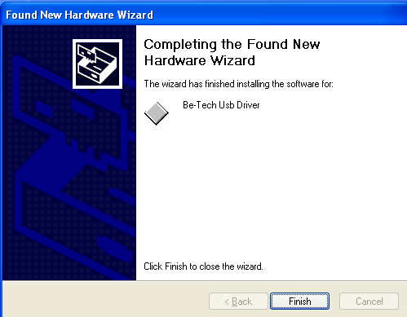

A. Change password of handset (change pw of handset)
Function: The default password of handset is blank. After changing password of handset, users must access to handset with the correct password next time.
Operation: choose this option, press "OK", enter a new password, press "OK", confirm the new password, press "OK", done.
B. Communicate with PC (communicate with PC)
Function: setup the handset on PC such as setting time, querying information, deleting date and so on.
Operation: connect with pc with appropriative line, and then choose this option, press "OK", done.
And the LED will show “Waiting for communication……”, if connection is faulty, it will show “connection failure”
Then go back to the software, find out the handset option, select
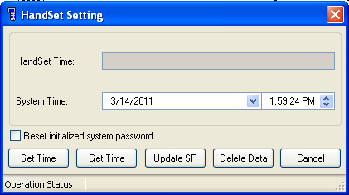
Set time: set up handset’s time
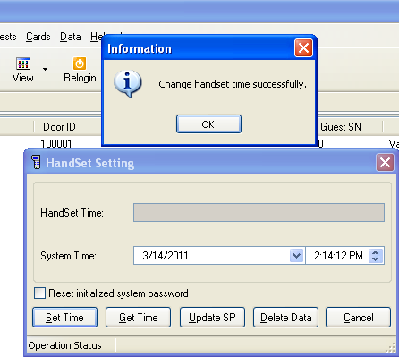

Get time: check handset’s time
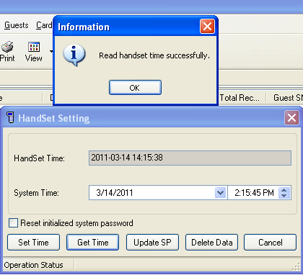
Update SP: Update handset’s SID as software SID, it means that the handset must have the same SID with software, if their SID is different, the key cards issued for encoder could not open the door.
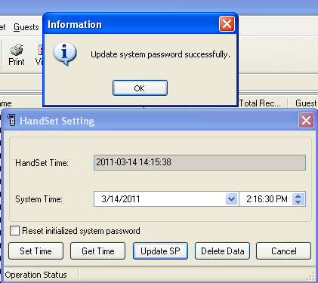

Delete data: Delete the old data of the handset, it will take about couples minutes.
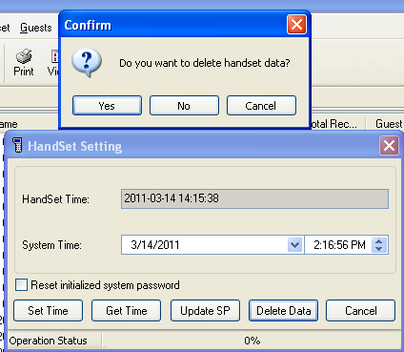

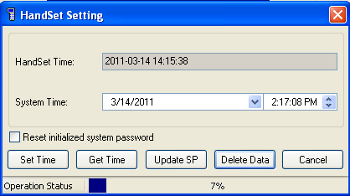

Write handset, go to the software and find out “handset”, the choose “setting information”, you will see a screen as below shows, then choose “Locks”, “OK” for next.

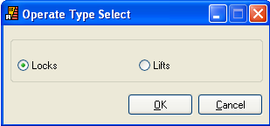

When you press “OK”, you will see all rooms on the left, basically, we choose all room and move them to right, so you press “”

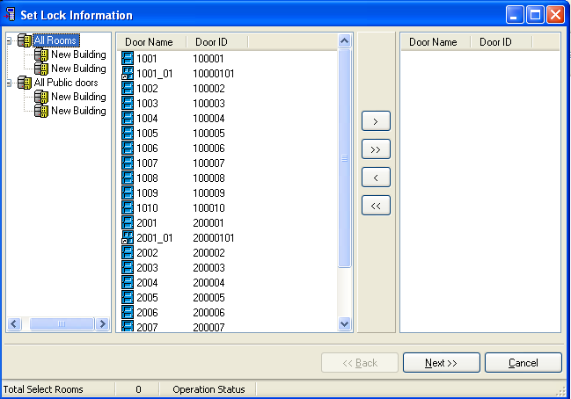
if you want to choose only one room, press “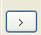”
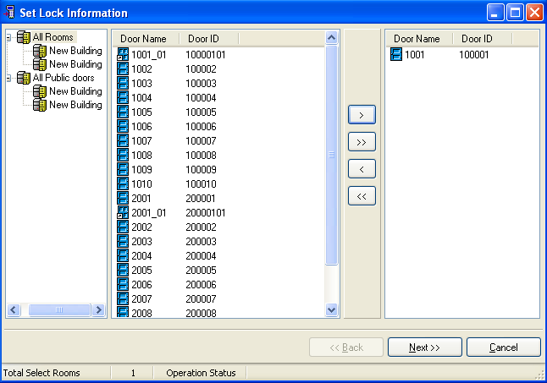
Press “next”
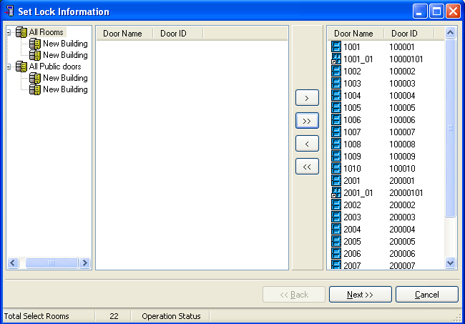
Time sections setting: press “set”, you will many time sections you can set, it is like the “time card”, choose “Reset guest information”, if locks are newly installed. And other tow options depend on requirement.
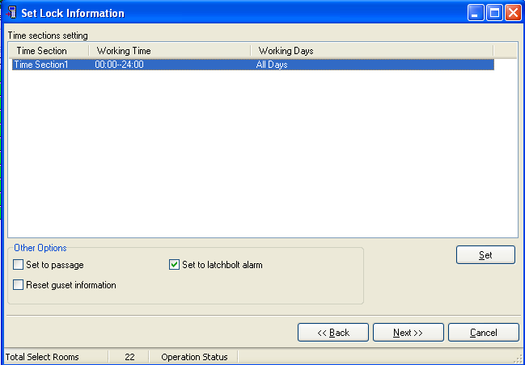

Blacklist setting: if some card is lost, in that case, you need to choose the lost card, and take it into right, and that card can not be used as all the information is transmitted into the locks. Then, press “next”,
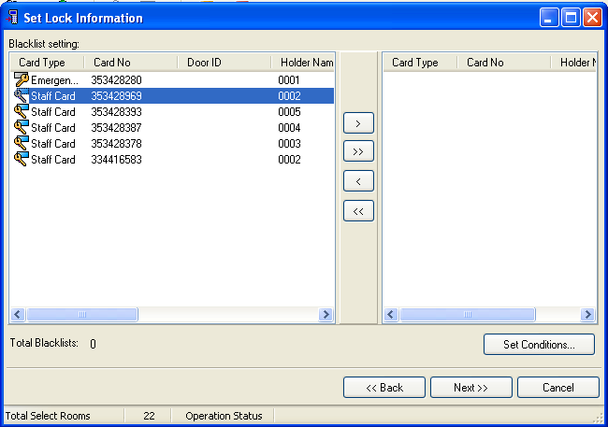

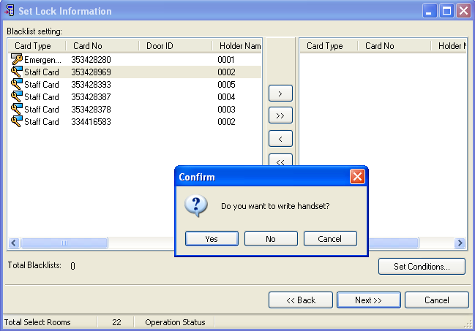

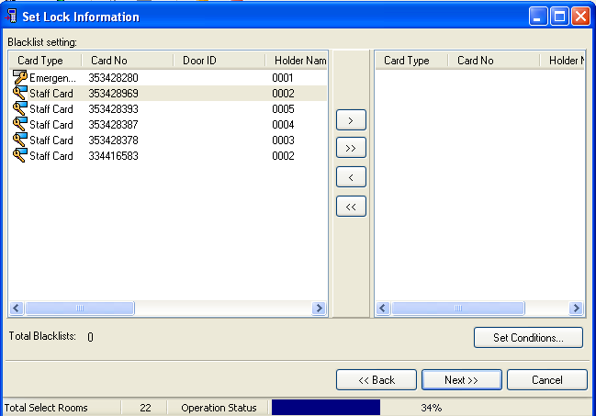

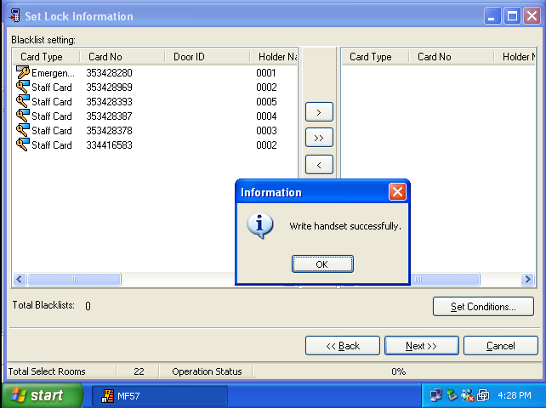

When you see “write handset successfully”, all the information of the hotel has been transmitted in the handset. The next step is going to set up the locks.
C. Setup system password (setup sys pw)
Function ：Setup/change system password of the lock.
Operation: connect with locks with appropriative line, and then choose this option, press "OK", done.
Operations:
Insert the USB-Mini USB wire, then go in front the lock, there is Mini USB socket at the bottom, connect handset with lock, then choose “ setup sys pw”---- “OK” ----“1 beep” comes from lock, setting is successful. Then move to “setup lock’s info”
D. Setup lock's information (setup lock's info)
Function: setup/change lock's information including lock's memory, motor's parameter, authorizing staffs, blacklist and so on
Operation: connect with lock with appropriative line, then choose this option, press "OK", wait for a moment, done.
Operation:
Choose “setup lock’s info”, press “OK”, you will see enter lock’s No., in that case, you can enter the locks’ No, and press “OK”, the lock’s No. is with 8 digits, the ahead 6 digits is same as “Door ID” in the software, and the last two digits are for inner door, without inner door is “00”, for example, if you want to find out the door ID is 100001 to set, the Door ID in the software is 100001, there is no inner door in this room, so you enter 10000100; if there is one inner room in Door ID 200002, then you can enter 20000201 to find out that room No.
In another case, once you see “enter lock No.”, keep pressing “OK”, you will see all the rooms; find out the corresponding room and setup.
E. Check lock's time (check lock's time)
Function：Check lock's current time.
Operation：Connect the lock with appropriative line, then choose this option, press "OK", done.
F. Adjust lock's time (adjust lock's time)
Function：Set the current time to the lock.
Operation: connect with lock with appropriative line, and then choose this option, press "OK", confirm the time and press "OK", done.
This is another important step for setting the lock, it is used for setting lock’s time, then choose “ adjust lock’s time”---- “OK” ----“1 beep” comes from lock, setting is successful, if you want to sure if the time has been set, you can use “check lock’s time”.
G. Check lock's battery (check lock's battery)
Function：Check lock's current battery.
Operation：Connect the lock with appropriative line, then choose this option, press "OK", it will display normal/low.
H. Download lock's info (download lock's information)
Function: download the current opening record of lock to handset
Operation: connect with lock with appropriative line, then choose this option, press "OK", wait for a moment, done.
Connect the lock with handset, choose the option, and press “OK”, it will take couples seconds to download the information from the lock.
After downloading the information, connect the handset with PC, and choose “communicate with PC”,

Go back to the software, find out the “Handset”, and choose “query information”, you will see the screen as below, and them press “OK”.

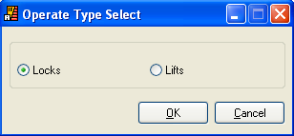

Press “read data”
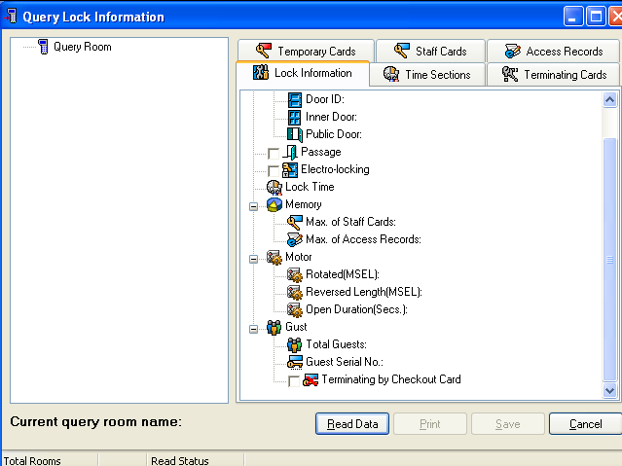
Press “Yes”.
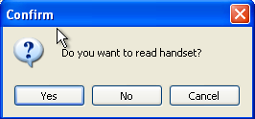
Notice: Do not move the device or load any other operation in PC when downloading the information.\
After downloading the information, you will see the screen as below, click the room you want, and then press “Query”,

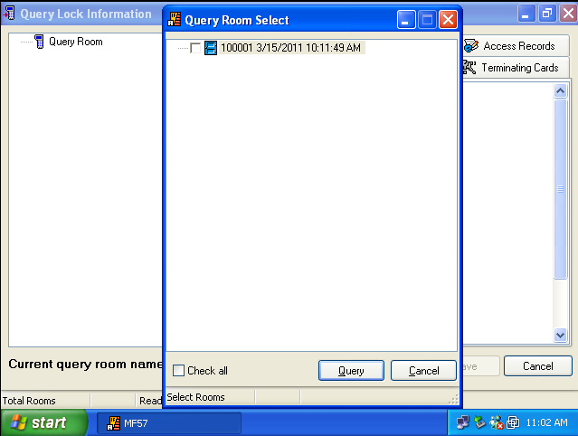
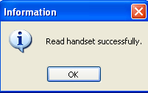

When “Read handset successfully” pops up, press “OK”, you will see another screen as below,
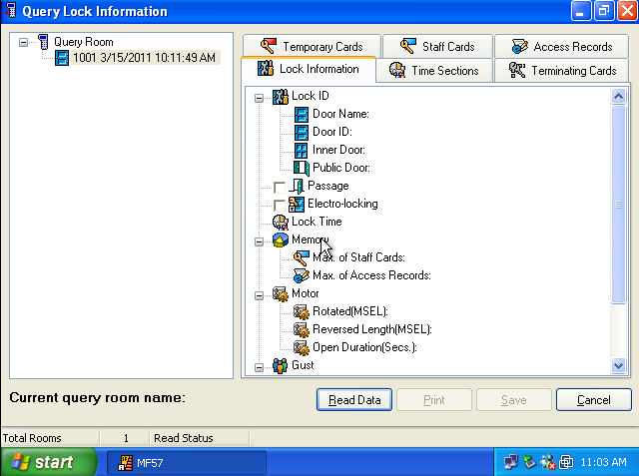

Choose the room and right click the mouse, and you will see “view”, press “view”, finally, you can see all the information of the lock.
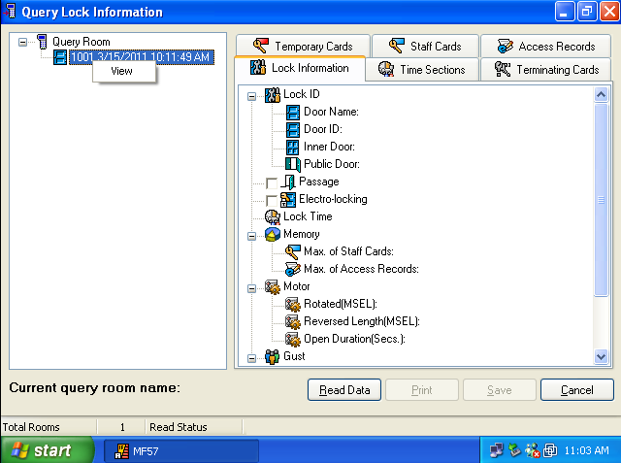

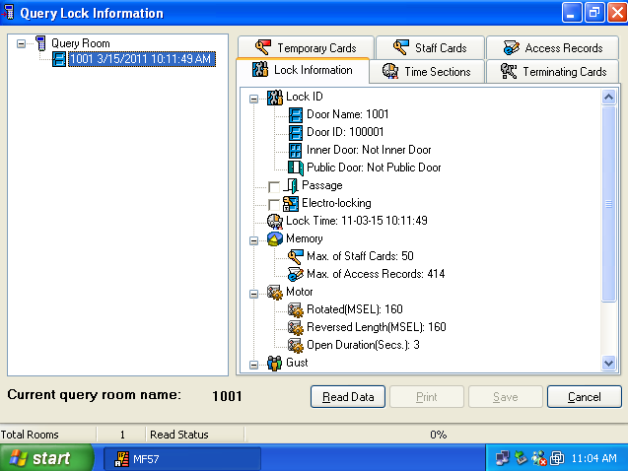
Notice: one handset can download several locks’ information. But need to view the information one by one.



